Draft Final Report

for:
ASHRAE 1449-RFP
Energy Efficiency and Cost Assessment of
Humidity Control Options for Residential Buildings

by:
Building Science Corp.
CDH Energy Corp.
University of Central Florida / Florida Solar Energy Center

19 June 2012

TABLE OF CONTENTS

1. Introduction 3
Overall Project Approach 4
2. Simulation Approach and Details 6
Overview 6
Climates 6
Building and Enclosure Thermal Details 7
AC System Details 11
Mechanical Ventilation Options 13
Space Conditioning Systems 17
Electric and Gas Costs 25
3. Simulation Results 26
Overview 26
HERS Level and Climate with Conventional AC 26
Evaluating Humidity Levels 31
Location of Ducts in the Conditioned Space 36
Impact of Ventilation Options 37
Constant Speed, Two Speed, and Variable Speed Air Conditioners 46
Enhanced Air Conditioner Options 48
Dehumidifiers 51
4. Conclusions and Recommendations 55
5. References 56

APPENDIX A – Critical Questions (developed as part of Task 2)

APPENDIX B – Detailed Description of Building Performance Levels

APPENDIX C – Comparing the Simulation Model to Measured Data

APPENDIX D – Modeling Approach for Two-Speed and Variable Speed Units

APPENDIX E – Models Developed for Dehumidifier Units

APPENDIX F – Model developed for Lennox Humitrol Unit

APPENDIX G – Model Developed for NovelAire Gas-Fired Desiccant Unit

APPENDIX H – Detailed Simulation Results

Introduction
Traditionally, the conventional residential air conditioning approach has been deemed adequate in terms of dehumidification for many situations and climates. In homes, air conditioning systems provide dehumidification as a consequence of sensible cooling. Since these systems are controlled based on a dry-bulb temperature set point, humidity is not explicitly controlled to a precise level but may still be maintained within an acceptable range (e.g., below 60%). However, as homes have become more energy efficient and explicit outdoor ventilation air is provided, this passive approach to humidity control may no longer be adequate.

Energy-efficient houses in warm, humid climates have low sensible heat gain. Low sensible heat gain is good for reducing cooling costs, but contributes to part load moisture control challenges (Rudd et al. 2003, Rudd et al. 2005). Especially during Spring and Fall seasons, as well as rainy periods and summer nights, there are a significant number of hours where little or no sensible cooling is needed but moisture removal is still needed due to internal moisture generation and outside air exchange. Conventional cooling equipment is designed mostly for reducing air temperature (sensible cooling), with only about 20 to 30 percent of its capacity typically devoted to removing moisture (latent cooling). This results in periods of high indoor relative humidity (Rudd and Henderson 2007).

Conventional space conditioning systems both cool and dehumidify air as a result of system operation. However, they cannot solely dehumidify. Some space conditioning equipment can slow the indoor fan and the compressor to get more moisture removal while the system is cooling for longer periods, but it continues to cool in order to dehumidify. In efficient, low heat gain houses in warm-humid climates, when no cooling is needed but moisture removal alone is needed, the solution has been to employ systems that can remove moisture while supplying room neutral temperature or warmer air (e.g., standalone room air dehumidifier).

Separate or integrated (BSC 2006) dehumidification equipment can be employed to supplement the operation of a normal cooling system during periods when moisture removal alone is needed. Conventional wisdom assumes that the heat added to the space by a dehumidifier provides additional cooling load that increases cooling operation (Proctor & Piro 2005, 111). Results from analysis by Henderson and Rice (2008) showed that the energy penalty due to dehumidifier heat addition is small because the dehumidifier often operates when the space dry-bulb temperature is below the cooling setpoint. This supplemental dehumidification capacity may also result in occupants being more comfortable at a higher cooling setpoint, which can reduce the net cost of dehumidification, but the more important factor is a health strategy to keep humidity levels low enough to discourage mold and allergens associated with high relative humidity.

Overall Project Approach
Task 1 of this research project detailed the current state of the art in dehumidification options used in the residential space conditioning industry through an extended literature search. Gaps in equipment performance information were identified in some cases, but mostly regarding inverter-driven variable refrigerant flow systems (mini- and multi-split ductless systems) that are becoming more common in recent years.

Task 2 developed a list of the critical questions to be answered throughout the rest of this project. These questions focused the scope of work needed to accomplish the stated objective of this research -- to evaluate, assess and rank the humidity control performance, energy efficiency, and cost of space conditioning systems for their capability to control indoor humidity throughout the year in humid climate residences, with a reference humidity control target level of less than 60% relative humidity. These critical questions are summarized in Appendix A.

Task 3 identified the model development needs that must be addressed in order to meet the objectives of this research effort. The most important of those areas related to the ability to properly model: variable speed ductless air conditioning systems and ducted two-speed systems; cooling systems using full condensing reheat; moisture evaporation for dehumidifiers that integrate ventilation; and full accounting for the combined effects of unbalanced duct leakage, unbalanced ventilation, and infiltration. More recent discussions have also indicated the need to upgrade the infiltration model to incorporate the methodology developed by Walker and Wilson (Walker and Wilson 1998, ASHRAE 2009). These model improvements were implemented (during Task 5) to provide more accurate and meaningful simulation results. These improvements are necessary to accurately represent integrated building/equipment performance so that the predicted performance of the different systems can be meaningfully compared.

Task 4 report defined the detailed strategy to be used for completing the simulations in Task 5. This modeling plan was developed to optimally reduce the uncertainty of answers to the crucial questions identified in Task 2. The strategy includes using a range of comfort conditions and moisture loads to assess the reported success or failure of evaluated humidity control options.

This final report presents and analyzes the simulation results and discerns the meaning and lessons from this data.

Simulation Approach and Details

Overview
This study used TRNSYS as the basis for the building and system simulations. Specifically TRN-ResDH, which previously developed by Hugh Henderson, was improved to meet the needs of this project. TRNSYS-based hour-by-hour building energy simulation tool, and will be used to simulate the HVAC technologies being investigated as part of this project. TRN-ResDH includes component models for various dehumidification systems of interest in this study, including conventional standalone room air dehumidifiers, high-efficiency mechanical dehumidifiers, subcool/condenser reheat systems, and desiccant dehumidification equipment. It also includes robust models for conventional AC components that accurately predict performance at part-load conditions. The impact of moisture capacitance in building materials and furnishings, moisture evaporation from the cooling coil when the compressor is off, and other impacts of fan performance are all considered in this simulation tool.

For this study the short-time-step version has been developed (0.02 hour, or 72 seconds) in order to properly consider all of the system control and performance interactions of multiple simultaneously operating machines that are critical to predicting energy consumption and resulting indoor humidity conditions.

Climates
The cities shown below, representing each of the IECC Climate Zones 1A through 5A shown in Figure 1, were chosen to represent locations that have, at least for part of the year, substantial latent loads, and cover a temperature range that includes both conditions with little coincident sensible load and significant coincident sensible load. TMY3 weather data is used. Orlando was not originally includes and added in the middle of the study.

Table 1. Climates Selected for Simulation
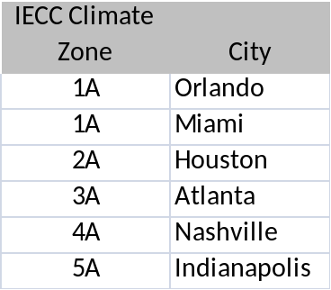
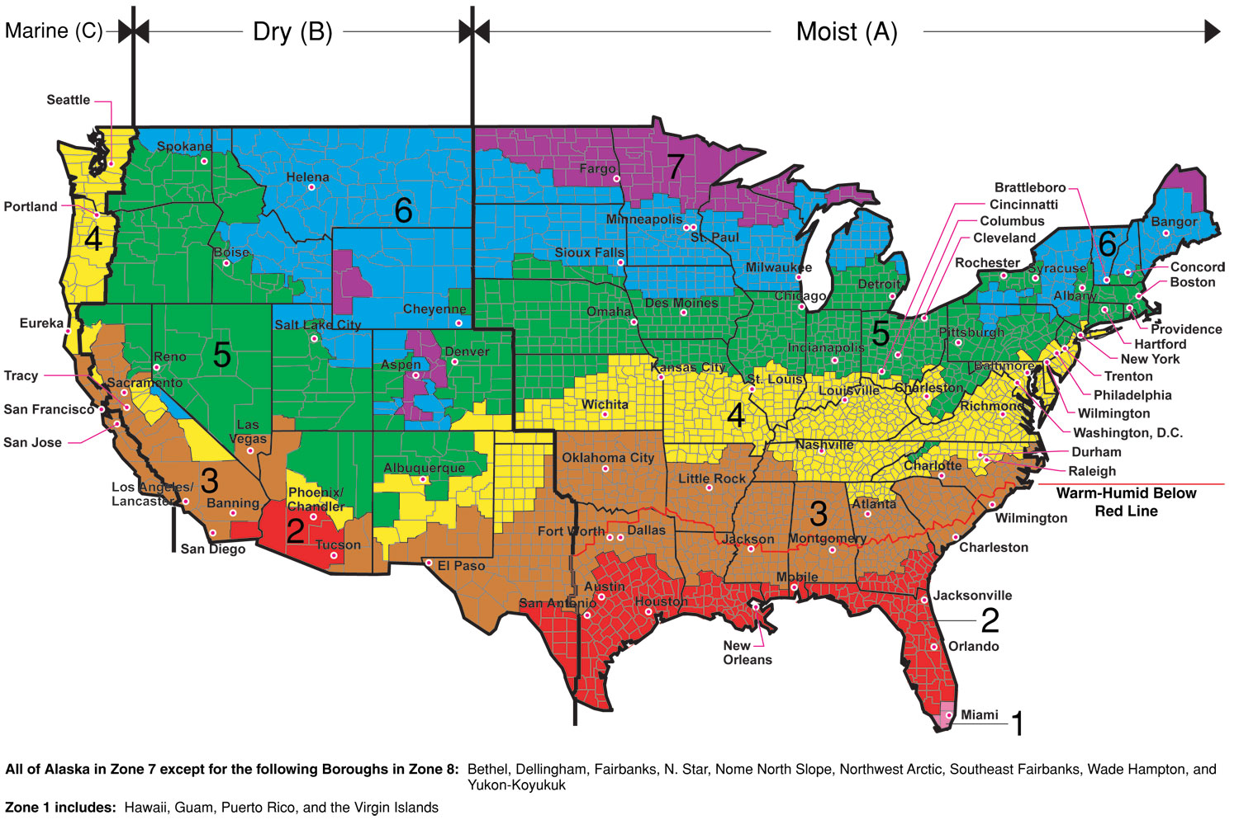
Figure 1. IECC Climate Zone Map

Building and Enclosure Thermal Details
The 2,000 ft² 3 bedroom house was modeled as slab-on-grade with a separate attic zone (a 2-zone model in TRNSYS Type 56). A range of building enclosures were simulated corresponding to Home Energy Rating System (HERS) levels that were selected to correspond to common industry benchmarks (see Table 2). The combination of building and mechanical system characteristics were chosen to reflect typical practice at each level. Therefore, higher efficiency AC systems were to specified at lower HERS Indices. Appendix B provides the thermal enclosure details for each house.

Table 2. Description of Performance Levels
Description or Benchmark | HERS Index | AC Efficiency
Typical Existing House | 130 | 10 SEER
HERS Reference House | 100 | 13 SEER
Energy Star House | 85 | 14.5 SEER (BPM fan)
Builders Challenge House | 70 | 17.7 SEER (two-speed)
Building America Prototype | 50 | 17.7 SEER (two-speed)

Building Enclosure Air Leakage

The AIM-2 infiltration model (Walker 1998, ASHRAE 2009) relates infiltration to wind and indoor-outdoor temperature difference for each timestep. All simulations in this study used coefficients representing shelter from buildings across the street. The equivalent leakage area (ELA) was varied to provide the desired ACH50 at each HERS level, as shown in Table 3.

The attic uses the same AIM-2 equations to determine leakage as a function of wind and temperature difference. The attic ELA was set to be 567 in² for all the HERS levels, or about 5 times the leakage rate for the HERS 100 house building enclosure (Walker ????).

Table 3. Envelope Leakage and Duct Performance
HERS Level | Target ACH at 50 Pa | ELA at 40 Pa  (in²) | Duct Leakage, Supply and Return Combined*  (% of flow) | Duct Insulation R-Value  (h-F-ft²/Btu) | Sup / Ret Duct Area (ft²)
130 | 10 | 140.1 | 20% | 6 | 544 / 100
100 | 7 | 98.1 | 10% | 6 | 544 / 100
85 | 5 | 70.1 | 5% | 8 | 544 / 100
70 | 4 | 56.1 | 5% | 8 | 544 / 100
50 | 3 | 42 | None | Na | Na
*Note: Duct leaks are assumed to be 60% on supply side, 40% on return side.

Duct Leakage and Thermal Losses

Table 3 also lists the characteristics of the duct system. For the HERS 130 to 70 Houses, the ducts were assumed to be located in the attic space and all the air leakage and thermal losses/gainsowhere in that zone. For the HERS 50 house the ducts were assumed to be in the conditiones space so leakage and thermal conduction had no impact. The duct leakage rates are assumed be 60% on the supply side and 40% on the return side for all the cases. Duct insulation is assumed to be R-6 for the HERS 130, 100 houses and R-8 for the HERS 85, 70 houses. tFrom a modeling perspective, the HERS 50 houses had no duct insulation since all ducts were inside conditioned space, although from a field perspective, duct insulation of R-4 would typically be used in Climate Zones 4A and lower to avoid any duct surface condensation.

Moisture and Thermal Gains

The scheduling or profile of internal heat and moisture generation was taken from the Building America Benchmark Definition (Hendron 2008). Sensible gains from all sources are assumed to be:
72.70 MBtu/day (21.3 kWh/day) for HERS 130 and 100
65.43 MBtu/day (19.2 kWh/day) for HERS.85
58.16 MBtu/day (17 kWh/day) for HERS 70
50.89 MBtu/day (14.9 kWh/day) for HERS 50

Internal moisture generation from all sources was specified as 12 lb/day or less than half of the ASHRAE Standard 160 moisture generation rate of 31.2 lb/day (1.3 lb/h) for a 3 bedroom house. The ASHRAE 160 value is meant to a “worst case” design condition and therefore would not be expected to correspond to average conditions. This value of 12 lb/day was selected based on a calibration effort (see Appendix C) to select key values that resulted in humidity distributions similar those observed from monitored homes.

Moisture and Thermal Capacitance

Moisture storage in the building materials and furnishings and the rate of mass transfer into storage are important hygrothermal parameters affecting the required capacity of dehumidification equipment along with the diurnal swings in indoor humidity. Building material moisture storage was modeled as a simple lumped parameter method with mass factor added to the air node in the zone model:

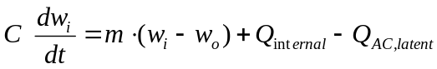

where: w - humidity ratio (lb/lb), i=indoor, o=outdoor
m - net indoor-to-outdoor airflow rate (lb/h)
Q_{internal} - Internal moisture gains (lb/h)
Q_{AC, latent} - moisture removal by air conditioner or dehumidifier (lb/h)
C - a capacitance term: air mass in space times multiplication factor

The moisture capacitance term is usually set to a multiple of the air mass inside the house. Shirey et al (2001) used more detailed moisture models including Effective Moisture Penetration Depth (EMPD) to show that reasonable factors for the air mass multiplier are 20 to 30 times the air mass.

As a result of the calibration efforts described in Appendix C, a 30x multiplier for moisture capacitance was used for the main zone. The attic used a moisture capacitance factor of 15x.

Thermal capacitance was simulated by adding internal walls to the model with 4,000 ft² (371.6 m²) of exposed wall surface area. The thermal mass of the air node was also increased by 20x to 12,331.2 kJ/K to reflect the impact of furniture and other material in the space. The attic is assumed have a thermal capacitance multiplier of 1x.

Window Performance

The window model in Type 56 uses the window parameters generated by LBNLs WINDOW5 software, which is considerably more detailed than the NFRC rating values generally discussed in residential practice and building codes. The LBNL WINDOW inputs for this project were determined following the methodology developed by Arasteh et al. (2009) for use in EnergyPlus.

The suitability of this model to TRNSYS was checked by comparing the fraction of transmitted solar radiation as calculated by TRNSYS to the nominal SHGC. The actual solar gains for the windows for the south facing wall were typically within -21% to +14% of the expected performance based on the nominal SHGC. The average difference for all the windows was zero.

Attic and Roof Heat Transfer

The house for this study was constructed with a two-zone model: 1) the main zone and 2) the unconditioned, vented attic zone. For all but the HERS 50 house, which has ducts inside conditioned space, the two zones are connected via an insulated ceiling. and the air conditioner ducts are located in the attic and interact with that zone. Return air leaks pull air from the attic zone. Supply air leaks and duct conduction losses tend to cool and dehumidify that zone.

The roof absorbance was set to 0.9 consistent with dark asphalt shingles. The convection coefficient from the exterior roof surface was adjusted to bring the peak temperature in the attic close to values observed in real homes. 32 kJ/h-m2-K was selected as most consistent with the expected attic temperatures. Similarly, Lixing Gu, a simulation expert and researcher at FSEC, reported that he typically uses 10 W-m2-K (36 kJ-h-m2-K) for the exterior heat transfer coefficient for modeling Florida homes.

AC System Details

The study considered both conventional cooling systems as well as other systems that provided improved humidity control. The size of conventional AC unit was determined for each climate and HERS level. This resulting manual J-sizing is given in Table 4. The smallest available unit was assumed to be 2 tons. This sizing was used for all systems.

Table 4. AC Unit Sizing for each Climate and HERS Level
 | AC Size per Manual J (tons)
 | HERS 130 | HERS 100 | HERS 85 | HERS 70 | HERS 50
0 – Orlando | 3 | 3 | 2.5 | 2 | 2
1 – Miami | 3 | 3 | 2.5 | 2 | 2
2 – Houston | 3 | 3 | 2.5 | 2 | 2
3 – Atlanta | 2.5 | 2.5 | 2 | 2 | 2
4 – Nashville | 2.5 | 2.5 | 2 | 2 | 2
5 – Indianapolis | 2.5 | 2.5 | 2 | 2 | 2
Note: Shading indicates where the sizing actually lower than assumed minimum of 2 tons

A range or air conditioners were required for this study. This detailed air conditioner model required separate inputs for the gross EER at nominal conditions, sensible heat ratio (SHR), and fan power. These 3 values are required to determine the resulting SEER for each AC system. These values are given in Table 5. The fan power assumed for rated conditions – and used to calculate SEER – is listed along with the actual fan power assumed for operation. For instance for the SEER 13 unit the assumed fan power at rated conditions was assumed to be 0.25 W/cfm, while the actual fan power was 0.5 W/cfm. Two-speed and variable-speed require additional parameters at low speed to define their performance. Table 6 lists these additional low speed parameters. Note that the low stage fan power for single speed systems was used for the System 2, which is described below.

Table 5. AC Unit Characteristics
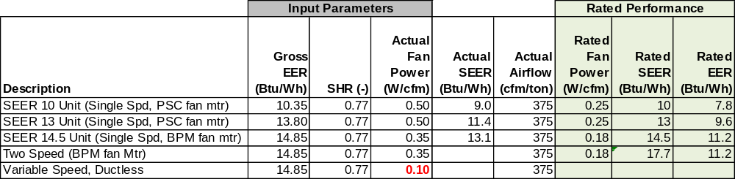
Note: Gross EER is total coil cooling capacity divided by compressor and condenser fan power at the nominal rating point: 95°F outdoors, 80°F/67°F entering coil and 450 cfm per ton supply air flow.

Table 6. Additional AC Unit Characteristics for Two-Speed and Variable Speed Systems
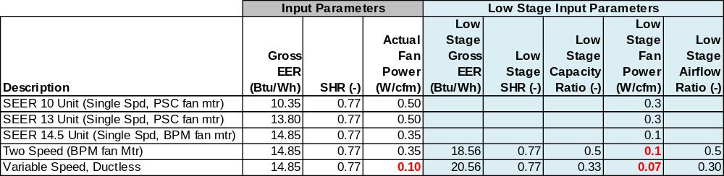
Note: Gross EER is total coil cooling capacity divided by compressor and condenser fan power at the nominal rating point: 95°F outdoors, 80°F/67°F entering coil and 450 cfm per ton supply air flow.

The airflow in the cooling mode is assumed to be 375 cfm per ton. In the heating mode the fan airflow is slightly lower at 275 cfm per ton. Any other fan operation for ventilation or mixing is also assumed to use the heating air flow rate. For the two-speed and variable speed units the airflow corresponding to the lowest stage (from the table above) is assumed to be used for ventilation or mixing.

Set Points
Thermostat set points for heating and cooling are listed in Table 7. The 70°F heating set point was selected as appropriate for temperate climates while the 72°F was deemed as more appropriate for the warm, humid climates (the original plan had been to use 68°F heating set point). The cooling set point of 78°F was selected as most consistent with homeowner preferences in warm climates and is also consistent with the HERS Reference House according to the 2006 Mortgage Industry National Home Energy Rating Systems Standards.

Table 7. Heating Cooling and Dehumidification Set Points
 | Heating Set Point (°F) | Cooling Set Point (°F) | Dehumidification Set Point (%)
0 – Orlando | 72 | 78 | 50% or 60%
1 – Miami | 72 | 78 | 50% or 60%
2 – Houston | 72 | 78 | 50% or 60%
3 – Atlanta | 70 | 78 | 50% or 60%
4 – Nashville | 70 | 78 | 50% or 60%
5 – Indianapolis | 70 | 78 | 50% or 60%

The impact of thermostat deadband and anticipator were explicitly considered in this short timestep model in the cooling mode as per Henderson (1992). The deadband was ±1°F around the desired temperature point. The anticipator temperature gain was 2.5°F and the time constant of anticipator was 90 seconds. The sensing element of the thermostat had a time constant of 300 seconds. The result is temperature “droop” with runtime fraction that about 2°F. In the heating mode a simple deadband of ±1°F around the set point was used without an anticipator.

For explicit dehumidification systems as well as for air conditioners with an enhanced dehumidification mode, the dehumidification set point was specified in terms of relative humidity. A deadband of ±1.5% around the target value was used. Two different humidity set points (50% and 60% RH) were considered corresponding to the often-stated expectations of different groups within the industry.

One variation on traditional dehumidification control is to reset the cooling setpoint based on the space humidity level. This overcooling control method (used in System 2 below) lowers the cooling set point by as much 2°F as the RH increases 12% above the set point. The degree of overcooling is linearly reset as the humidity increases above the set point. While in the overcooling mode, compressor operation is limited to 50% (10 minutes ON, 10 minutes OFF)

Mechanical Ventilation Options
Several ventilation options were considered in this study, including:
- Exhaust fan only
- Supply - Central fan integrated
- Heat recovery ventilator (HRV), with AHU mixing
- Enthalpy Recovery Ventilator (ERV), with AHU mixing

Figure 2 shows the air flow configuration used for each ventilation system. All these mechanical ventilation options provide an average rate of 58 cfm required by ASHRAE Standard 62.2 for the 2000 ft² 3 bedroom house. The HERS 130 was also modeled with no mechanical ventilation (infiltration only).

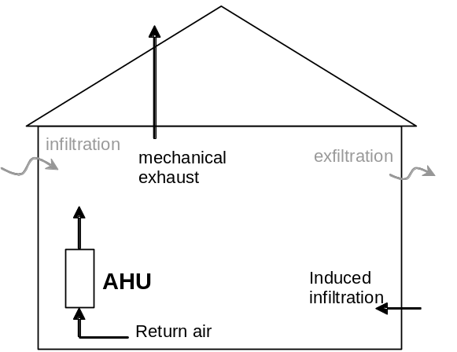  Exhaust Only  (exh fan operates 100% of hour) | 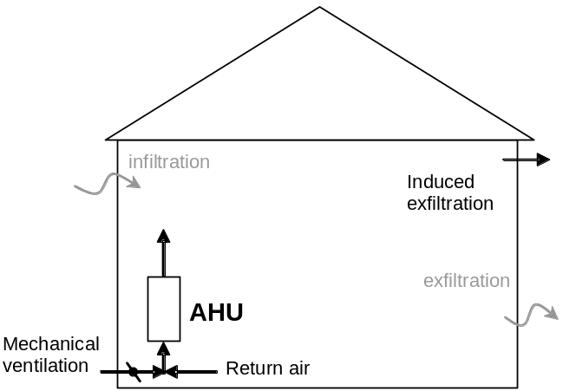  Supply - Central Fan Integrated  (damper/AHU operates 34% of hour @ 3x flow)
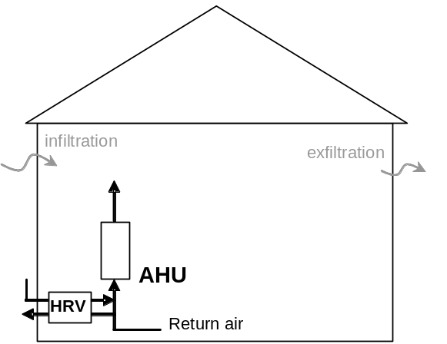  Balanced HRV / ERV – Ducted AHU  (HRV & AHU operates 50% of hr @ 2x flow) | 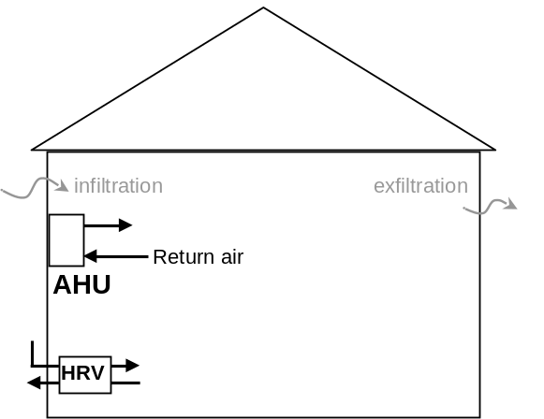  Balanced HRV / ERV – Ductless AHU (Sys 4)  (HRV operates 50% of hr @ 2x flow)
Figure 2. Schematic of Mechanical Ventilation System Options

The combined impact of infiltration, ventilation, and duct leakage were considered by using the equations below. The duct leakage is always a net out, so that additional net flow is an exhaust.

cfm_{in} = sum of all incoming ventilation flows (vent cfm at AC, dehum/vent unit, etc)
cfm_{out} = sum of all exhaust flows (exhaust fan, net duct leakage, etc)

cfm_{balanced} = MIN(cfm_{in}, cfm_{out})

cfm_{unbalanced} = MAX(cfm_{in}, cfm_{out}) - cfm_{balanced}

cfm_{inf} = infiltration flow calculated for building for the timestep

cfm_{combined} = MAX(cfm_{unbalanced} , cfm_{inf} + 0.5* cfm_{unbalanced} ) + cfm_{balanced}

Some fresh air is provided as part of the mechanical system. Therefore, the net mechanical inlet flows are subtracted from cfm_{combined} to determine the remaining non-mechanical ventilation (or infiltration) rate acting on the building envelope. A mass balance tracks CO₂ levels in the space and confirms the net impact of ventilation are similar between the cases.

Exhaust Only. The exhaust fan runs 100% of the time (independent of the AC unit) to provide the necessary ventilation for the house. The exhaust fan power is assumed to be 0.4 Watt/cfm.

Supply – Central Fan Integrated. A fresh air damper is installed on the return side of the air conditioner. The supply air fan runs a minimum of 34% of each hour (at heating speed, fan power is 0.4 Watt/cfm) to provide the necessary ventilation for the house. The fresh air damper is open during fan operation for no more than 34% of each hour The ventilation damper provides 174 cfm of fresh air regardless of the airflow rate (heating or cooling airflow).

Balanced Ventilation – ERV/HRV. An Energy Recovery Ventilator (enthalpy wheel) or Heat Recovery Ventilator (sensible heat exchanger) is installed to provide balanced ventilation. The assumed performance is

ERV effectiveness: 70% sensible, 60% moisture effectiveness
HRV effectiveness: 75% sensible

The ventilation airflow through the ventilator was twice the ventilation requirement but the fans only runs 50% of each hour (initiated at the top of the hour). The fan power is 0.5 Watt/cfm based on the ventilation flow. The ERV/HRV pulls exhaust air from the return side of the central air distribution system (or from the house) and supplies tempered fresh air back to the return duct (see Figure 2). The air handler unit (AHU) supply fan is interlocked with HRV/ERV fan to ensure good distribution of the ventilation air. The AHU fan operates at the lowest required airflow when there is not a call for cooling.

These mechanical ventilation options were implemented for each of the AC system options described below. One change implemented in this newest version of TRN-RESDH was to allow for a Dehumidifier to be combined with the HRV/ERV option, so this combination could be considered. The ventilation options are not required in combination with System 7 (Dehumidifier with ventilation). This system provides ventilation in conjunction with dehumidification, so it does not require a separate ventilation option.

The other slight variations or exceptions are the two-speed air conditioner (System 3) which as a very small minimum airflow, therefore the ventilation rate for the central fan integrated supply option is assumed provide 116 cfm of ventilation 50% of the time (instead of 174 cfm 34% of the time). The variable speed Air conditioner (System 4) is a ductless unit, so the CFI option is not possible. The fan on the ductless AC is still assumed to run at low speed in conjunction with the HRV/ERV to provide some degree of mixing.

Space Conditioning Systems

Fourteen (14) cooling and dehumidification systems were identified for evaluation in the Task 1 report. These systems are summarized in Table 8. Specific details for each system are given below.

Table 8. Summary of Space Conditioning Systems
System No | System Description | Control Based on Humidity Set Pt? | AHU Mixing Required
1 | Conventional DX System | No | No
2 | Conventional DX System with Lower Air Flow and Thermostat Overcooling | Yes (reset) | No
3 | Two-Speed Conventional DX System | No | No
4 | Variable Speed Mini-Split DX System | No | No
5 | Stand-Alone Dehumidifier with Conventional System Mixing | Yes | Yes
6 | Ducted Dehumidifier with Conventional System Mixing | Yes | Yes
7 | Ducted Dehumidifier with Outdoor Air Preconditioning | Yes | Yes
8 | Enhanced Cooling with Partial-Condensing/Subcooling Reheat (single speed compressor) | Yes | No
9 | Enhanced Cooling with Full Condensing/Subcooling Reheat  (2-speed compressor) | Yes | No
10 | Conventional DX System with Lower Air Flow | Yes | No
11 | Conventional DX System with Thermostat Overcooling | reset | No
12 | Conventional DX System with Sensible-Only AAHX | No | No
13 | Gas-Regenerated Desiccant Dehumidifier | Yes | Yes
14 | DX Condenser-Regenerated Desiccant Dehumidifier | Yes | Yes

System 1 – Conventional DX System. A conventional, single-speed DX air conditioner (air-cooled condenser) with a PSC fan motor (SEER 13). The system has a “gross” EER of 13.8 Btu/Wh at Rated Conditions. In cooling the system operates at a supply airflow rate of 375 cfm/ton with corresponding fan power of 0.5 Watts/cfm. The Heating airflow is 275 cfm/ton.

System 2 – Conventional DX System with Lower Air Flow and Thermostat Overcooling. Same as System 1 above but with controls to provide lower airflow (reduced to 200 cfm/ton) and space overcooling (as much as 2°F below setpoint) when space humidity is high). When space humidity increases above the RH set point, the cooling set points is reduced to continue cooling operation. While in the overcooling mode, compressor operation is limited to 50% runtime (10 minutes ON, 10 minutes OFF). The operating fan power for PSC motor fan drops from 0.5 to 0.3 W/cfm at low airflow. The operating fan power for brushless permanent magnet (BPM) motor drops from 0.35 to 0.1 W/cfm at low airflow.

System 3 – Two-Speed Conventional DX System. A two-speed AC unit with a gross EER of 14.85 Btu/Wh at high speed and approximately 18.56 Btu/Wh at low speed. Low speed is half of high speed capacity. The resulting SEER is 17.7 Btu/Wh. The operating supply air fan power with the ECM motor is 0.35 W/cfm at 375 cfm/ton for high speed. Compressor capacity and airflow drop at the same proportion to maintain the same cfm per “delivered ton”. Table 6 shows the detailed characteristics that define this unit.

Since the different HERS levels required different air conditioner efficiencies, the difference between HERS level and System are not always clear. Table 9 summarizes which air conditioner was used with each HERS level and System. The HERS 50 and 70 actually used the 14.5 SEER unit for System 1 as a sensitivity. Therefore, the default air conditioner for HERS 50 and 70 are actually the listed under System 3. The gray-shaded entries in the table show the default air conditioner used for the conventional air conditioner at each HERS level. Systems 5 and higher use the 17.7 SEER two-speed as the AC system for HERS 50 and 70 (except for Systems 8, 9 and 12, which are discussed below).

Table 9. Matrix of AC Conditioner Systems Used with each HERS Level and System
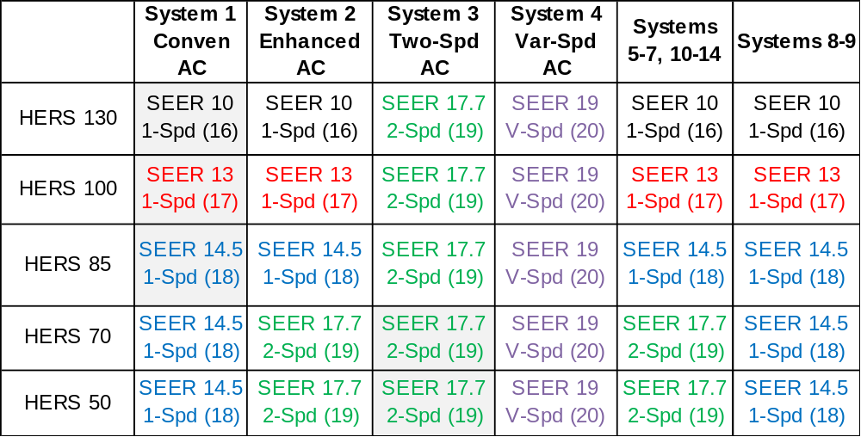
Note: The number in parentheses is the unit index in TRNSYS

System 4 – Variable Speed Mini-Split DX System. A variable-speed, ductless air conditioner unit with the ability to modulate air flow with compressor speed. The system characteristics will be selected to achieve an SEER over 20. Table 6 shows the detailed characteristics that define this unit. The operating fan power is 0.1 W/cfm at 375 cfm/ton for high speed compressor operation (Larson 2010). Lower compressor speeds allow for a lower supply air flow rate per “delivered ton” with correspondingly lower fan power.

System 5 – Stand-Alone Dehumidifier with Conventional System Mixing. A portable, stand-alone dehumidifier (DH) supplements the air conditioner. A small 50 pint/day dehumidifier with an Energy Factor (EF) of 1.55 liters/kWh at AHAM rating conditions . The dehumidifier operates operates to maintain the dehumidification set point independently of the conventional air conditioner. Fan controls ensure that the AHU supply fan runs 7 to 11 minutes of at each hour (depending on the supply airflow) to provide mixing in the space corresponding to a turnover rate of 0.5 Air changes per hour. Since this DH unit is ductless it does not have separate fan power.

System 6 – Ducted Dehumidifier with Conventional System Mixing. A slightly larger 64 pint/day ducted dehumidifier with an EF of 1.98 liters/kWh at AHAM rating conditions. This ducted unit includes a fan that is integrated with the AC unit in a recirculation configuration (pulling air from the main zone and then supplying air into the AHU supply duct). This configuration requires that the dehumidifier unit have a backdraft damper to ensure the AHU supply fan does not drive airflow backwards through the unit when the DH is off. The dehumidifier operates to maintain the required humidity set point. The equipment performance map for this unit was based on a UltraAire 70H unit that was tested in the NREL HVAC lab by Winkler et al (2011).

The airflow through the 64 pint/day dehumidifier was assumed to provide 135 cfm with a fan power of 0.7 W/cfm. The extra fan power for this ducted system, reflects the airflow and fan data provided by the manufacturer (Thermastor 2010). Fan controls ensure that the conventional AC supply air fan runs 7 to 11 minutes of at each hour (depending on the supply airflow) to provide mixing in the space corresponding to a turnover rate of 0.5 Air changes per hour.

System 7 – Ducted Dehumidifier with Outdoor Air Preconditioning. Larger 82 pint/day dehumidifier with an EF of 1.98 liters/kWh at AHAM rating conditions. This ducted unit includes a fan that is integrated with the AC unit in a ventilation air pre-conditioning configuration. The dehumidifier fan operates to bring in 67% return air and 33% ventilation air (a ratio of 2 to 1). Therefore, the total flow of 174 cfm through the dehumidifier includes 58 cfm of ventilation air. The dehumidifier fan runs continuously to provide the required ventilation airflow. The supply air from the dehumidifier unit is discharged into the AC supply duct. The dehumidifier compressor operates in response to the humidity set point. The equipment performance map for this unit was based on a UltraAire 70H unit that was tested in the NREL HVAC lab by Winkler et al (2011).

Fan controls ensure that the AC supply air fan runs 7 to 11 minutes of at each hour (depending on the supply airflow) to provide mixing in the space corresponding to a turnover rate of 0.5 Air changes per hour.

System 8 – Enhanced Cooling with Partial-Condensing/Subcooling Reheat. Central DX cooling system with refrigerant subcooling/reheat coil. Based on the two-speed AC unit (System 3) described above, but with enhanced mode operation when humidity is high (i.e., control scheme based on Lennox Humiditrol system). Specifics regarding this system’s dehumidification operating mode are provided in the Task 1 report (Section 4.4.1).

System 9 – Enhanced Cooling with Full Condensing/Subcooling Reheat. Central DX cooling system with modulating hot gas reheat providing full condensing and subcooling at an indoor reheat coil. Based on the two-speed AC unit (System 3) but with slightly higher fan power to reflect impact of added reheat coil (0.45 Watt/cfm at high speed; 0.22 Watt/cfm at low speed) (Ueno 2010). Specifics regarding this system’s dehumidification operating mode are provided in the Task 1 report (Section 4.4.2).

******* Sensitivity studies only for the following systems

System 10 - Conventional DX System with Lower Air Flow. Similar to System 2 but only includes controls to provide lower airflow (reduced to 200 cfm/ton) when space humidity rises above the set point.

System 11 - Conventional DX System with Thermostat Overcooling. Similar to System 2 but only includes controls to allow for space overcooling by as much as 2 F below the cooling setpoint) when space humidity is high increases above the set point. The reset schedule linearly varies the about overcooling in proportion to the increase in RH above the dehumidification set point.

System 12 – Conventional DX System with Sensible-Only AAHX. Conventional air conditioner with sensible air-to-air heat exchanger (AAHX) added for improved dehumidification performance (e.g., heat pipes). The heat pipe is assumed to be a non-condensing, aluminum fin, 1/2 inch O.D. copper tube, 2 row, 11 fpi. Face area of the heat pipe is set equal to the AC tonnage). The operating fan power increases to 0.55 Watt/cfm and the airflow drops to 350 cfm/ton to account for the additional heat exchanger pressure drop compared to System 1. This system uses the 14.5 SEER single-speed AC in the HERS 50 an HERS 70 houses (since two-speed operation would result in condensing on the heat pipe at low speed).

System 13 – Conventional DX System with Gas-Regenerated Desiccant Dehumidifier. Conventional AC unit with gas-regenerated desiccant dehumidifier (e.g., NovelAire ComfortDry 400). The unit pulls in regeneration air from outdoors and then exhausts it back to outdoors. The 400 cfm unit has a dehumidification capacity of 6.3 lb/h (145 pint/day) at AHAM rating conditions. Gas consumption is 10,000 Btu/h. The process side of the desiccant unit is arranged to pull air from the supply duct (downstream of the cooing coil) and provide dehumidified process air back to the AC supply duct, as shown in Figure 3. The process (or supply) side fan power is 0.6 Watt/cfm. Fan controls ensure that the conventional AC supply air fan runs 7 to 11 minutes of at each hour (depending on the supply airflow) to provide mixing in the space corresponding to a turnover rate of 0.5 Air changes per hour.

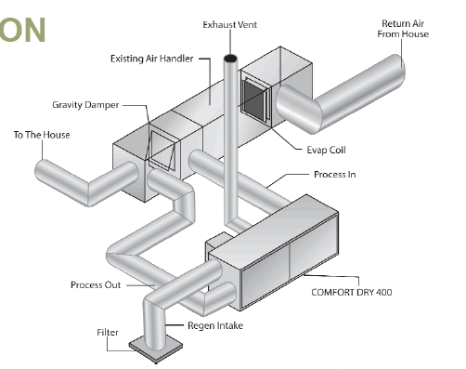
Figure 3. Configuration of Gas-Fired Desiccant Unit (pulling air from the AC outlet; supplying to supply duct)

System 14 - DX Condenser-Regenerated Desiccant Dehumidifier. Conventional air conditioner with a desiccant system regenerated by condenser waste heat from its small internal compressor (e.g., Munters HCU or the NovelAire 300). The Munters DryCool HD unit’s dehumidification capacity is about 5.2 lb/h at 250 cfm (120 pints per day). The unit’s energy factor is 3.3 liters/kWh (excluding supply fan power). The supply fan is estimated to be 250 cfm at 175 Watts (0.7 W/cfm). Controls ensure that the conventional AC supply air fan runs at least a few (e.g., 7) minutes out of every hour to provide mixing in the space (zone air mixing rate of 0.5 ACH). A performance map for the this desiccant unit has been developed data from the software tool available from the Munters/ DryCool HD website (version 1.0.4.0).
Summary of Dehumidifier Configurations
Figure 4 schematically shows the configuration for the dehumidifier and desiccant systems. We have generally assumed that ducted dehumidifiers and desiccant systems will supply air into the supply trunk of the main air handler unit (AHU). This helps to distribute dehumidified air throughout the house. However, practical experiences with these systems have shown that some AHU fan operation will still be required to provide adequate air distribution. Therefore, the supply air fan will be required to operate for a minimum fraction of each hour to provide a desired air mixing rate for the space. The AHU supply fan is operated to provide a turnover rate of 0.5 air changes per hour.

Electric and Gas Costs

Total HVAC costs (cooling, heating, fans) were determined using the electric and gas rates from Table 10. The heating load was tracked as kWh with no efficiency losses. Therefore, heating costs were determined by assuming a 90% efficient gas furnace and using the gas costs from the table below.

Table 10. Electric and Gas Costs
 | Electric Utility | $/kWh | $/therm
Z0 – Orlando | FPL | 0.101 | 1.79
Z1 – Miami | FPL | 0.101 | 1.79
Z2 – Houston | Entergy | 0.085 | 1.08
Z3 – Atlanta | Georgia Power | 0.103 | 1.52
Z4 – Nashville | Nashville | 0.097 | 1.05
Z5 – Indianapolis | Indianapolis PL | 0.078 | 0.86
Notes: Electric costs are from Form 826 data for local utility in 2010 for residential. Gas costs are average residential rate for state in 2010.

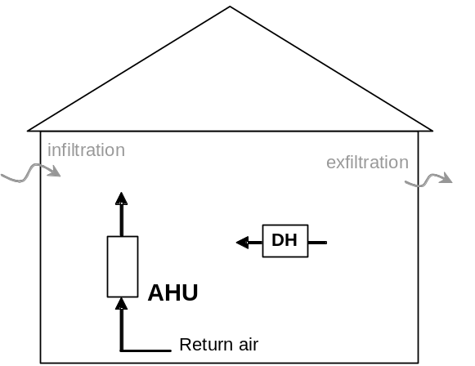  Stand-Alone Dehumidifier (System 5) | 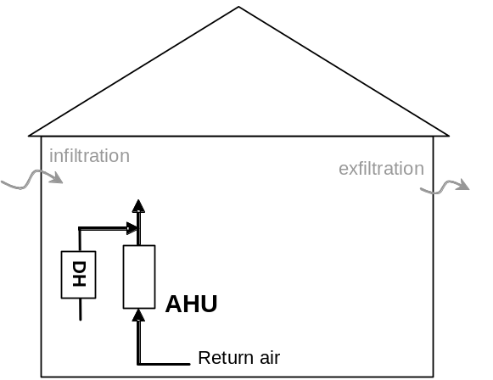  Ducted Dehumidifier (System 6)
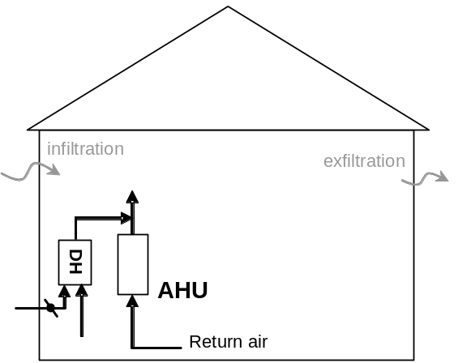
Ducted Dehumidifier with OA (System 7)
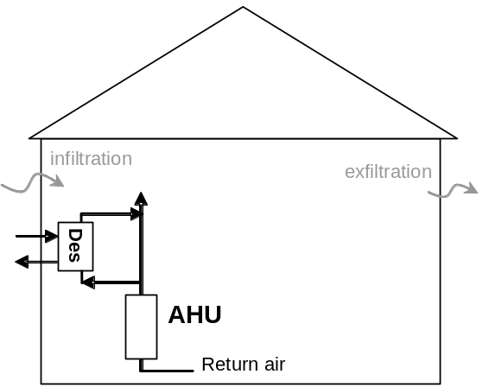  Gas-Fired Desiccant DH (System 13) | 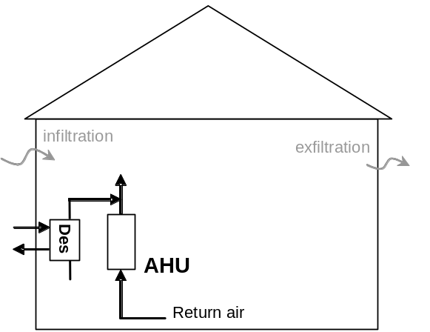  Desiccant Dehumidifier (System 14)

Figure 4. Schematic of Configurations for Dehumidifier and Desiccant Systems

Simulation Results

Overview
Several hundred simulations were run for the various climates, buildings, systems, RH set points and ventilation options. The designation for the each run follows the nomenclature listed below:

Z1 H100 S1 RH50 V1

Z0 = Orlando  Z1 = Miami  Z2 = Houston  Z3 = Atlanta  Z4 = Nashville  Z5 = Indianapolis | HERS50  HERS70  HERS85  HERS100  HERS130 | S1 = System 1  ….  S14 = System 14 | RH50 = 50% RH  RH60 = 60% RH | V0 = No Vent  V1 = Exh Fan  V2 = CFI  V3 = HRV  V4 = ERV

Summary data from all the annual simulation runs are available at a website ???? and in Appendix H. The sections below summarize the results focusing on various trends and themes.

HERS Level and Climate with Conventional AC
Simulations were run for houses at 5 different HERS levels and in 6 climates. The results are listed in Table 11. The HERS 130 level was run for the case with the ASHRAE 62.2 recommended ventilation rate via an exhaust fan (V1) as well as for the case without mechanical ventilation (V0, to represent the current housing stock). All other HERS levels used an exhaust fan for ventilation.

Figure 5 compares the total costs for the different HERS and climates using the data from Table 11. The relative costs are approximately (but not precisely) in line with the ratios implied by the HERS level (see Table 12).
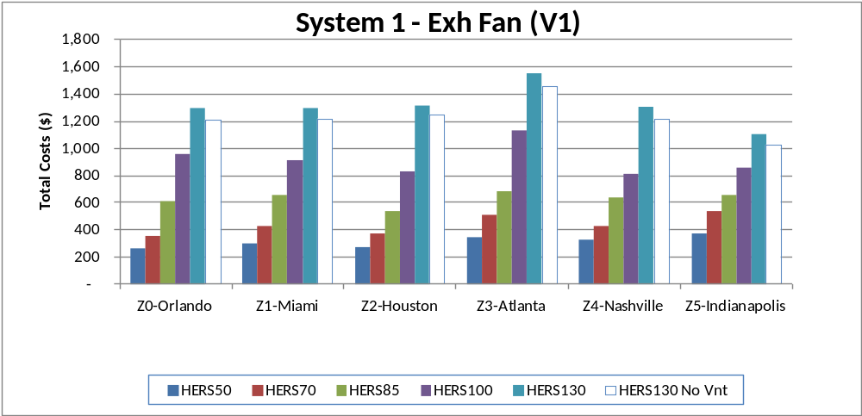
Figure 5. Comparing Total Costs for Different Climates and HERS Levels

Table 11. Performance Results for Different HERS Levels and Climates
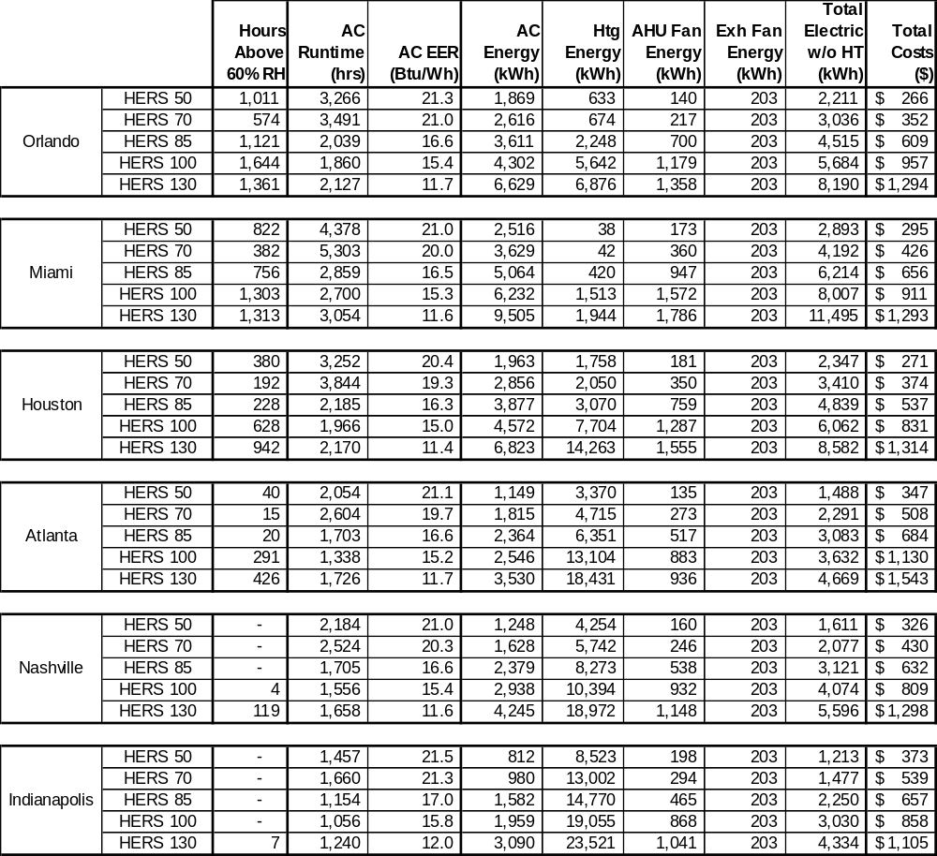

Table 12. Comparing Relative Annual Costs for each HERS Level and Climate
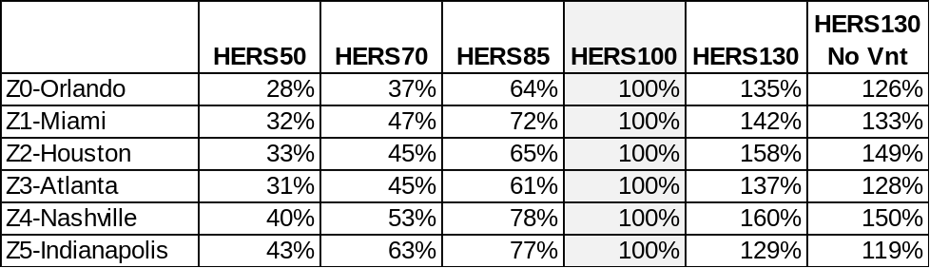

If heating energy is excluded (designated Total Electric w/o HT), the electric use in Miami is greater than the other climates (see Figure 6), followed by Houston and Orlando. The air conditioner operating hours are also significantly greater in Miami, as shown in Figure 7. The annual runtime for the two-speed AC units in the HERS 50 and 70 houses is also much greater than the single speed units in the other houses since the unit runs at low speed for long periods of time.

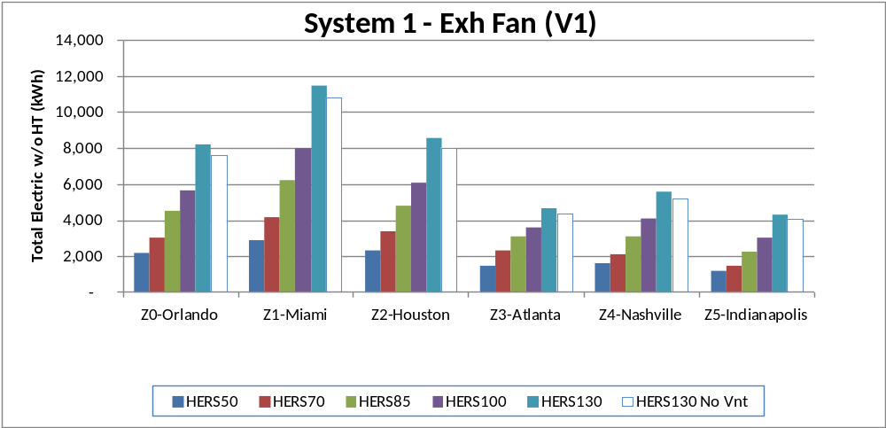
Figure 6. Comparing Cooling and Fan Energy Use for Different Climates and HERS Levels
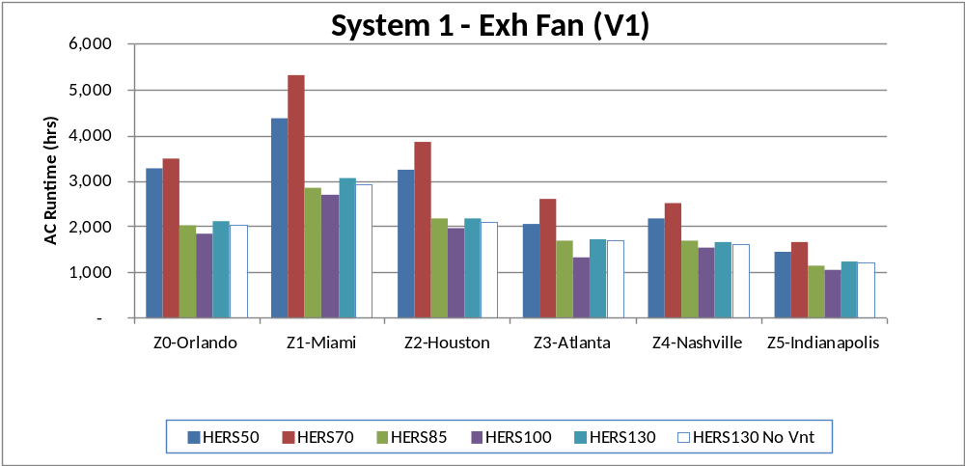
Figure 7. Comparing Air Conditioner Runtime for Different Climates and HERS Levels

The resulting annual EER for the cooling system in each scenario are compared in Figure 8. The EERs are based on gross cooling capacity (w/o fan heat) and using power for the outdoor unit only. The HERS 130 cases use a SEER 10 unit and result in gross annual EERs around 11-12 Btu/Wh. The HERS 85 and 100 houses with a 13 and 14.5 SEER units results in gross EERs near 15 and 16 Btu/Wh. The HERS 70 and 50 houses use two speed units with 17.7 SEER that result in a gross EERs exceeding 21 Btu/Wh.

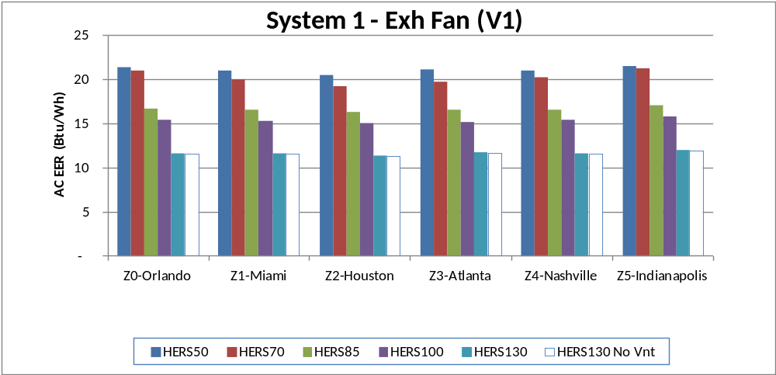
Figure 8. Comparing Air Conditioner EER for Different Climates and HERS Levels

Evaluating Humidity Levels
Humidity in the space is not directly controlled by the AC unit, so humidity levels typically vary across the year. The psychrometric chart in Figure 9 shows the average daily conditions observed across the year for the HERS 100 house in Miami with System 1. The days with cooling operation are shown as blue. The total number of hours over 60% RH are 1,303 per year. Most of these hours occur in Miami when the AC unit is off for the day. Figure 10 is a shade plot that shows the humidity bins for each hour of the year with shades of gray. Each day is shown as a vertical stripe on the plot. Successive days are are shown along the X axis. Darker shades indicate hours with higher humidity levels (0 corresponds to light gray, 5 is black). This plot confirms that high humidity does not occur in the summer but tends to happen in swing seasons and in the winter when little or no cooling operation is required. Finally, Figure 11 is a histogram shown the distribution of hours in the year at each humidity for Miami, HERS 100, System 1 with an exhaust fan.
The most common metric for gauging the prevalence of high humidity is the number of hours above some threshhold per year. Figure 12 includes three plots comparing the number of hours above 60%, 55%, and 50% RH, respectively. While there is not hard requirement or limit on humidity, we believe hours above 60% is a reasonable gauge when comparing different systems. The three different plots essentially show the same patterns when comparing the HERS level and the climates. Other metrics such as the number of high humidity events of certain duration also shows the same result. Figure 13 shows the number of events where the humidity was above 60% RH for periods of 4 hours and 8 hours, respectively.
The results in Figure 12 show the expected trends. The HERS 130 house without ventilation typically has lower humidity levels. When ventilation is provided to the house the hours of high humidity increase. Orlando generally has the highest levels, followed by Miami and Houston. As the HERS level is decreased, the hours of high humidity trend to decrease and are lowest for HERS levels of 70 and 85. The hours of high humidity increase again for the HERS 50 house, when ducts are moved into the conditioned space. The next section explores the impact of duct location in greater detail.

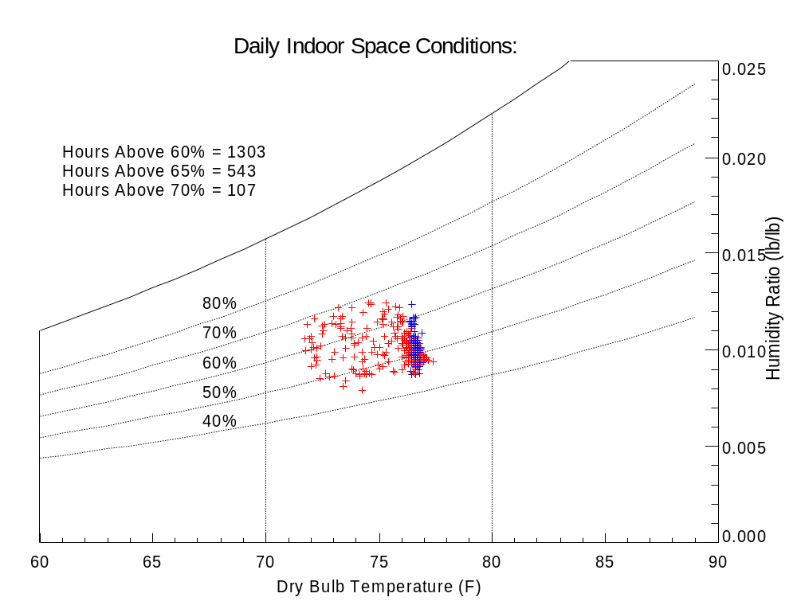
Days with Cooling Operation
Figure 9. Psychrometric Chart Showing Space Conditions for HERS 100, Miami, System 1, Exhaust Fan
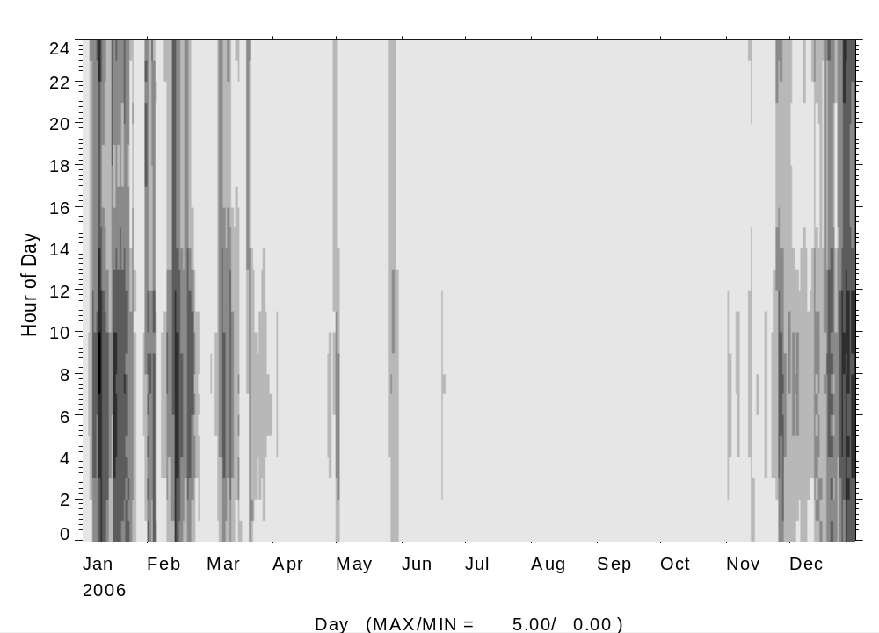
Shades of Gray
0 – below 55%
1 – 55-60%
2 – 60-65%
3 – 65-70
4 – 70-75%
5 – above 75%

Figure 10. Shade Plot showing Humidity “bins” for each Hour of Year for HERS 100, Miami, System 1, Exhaust Fan
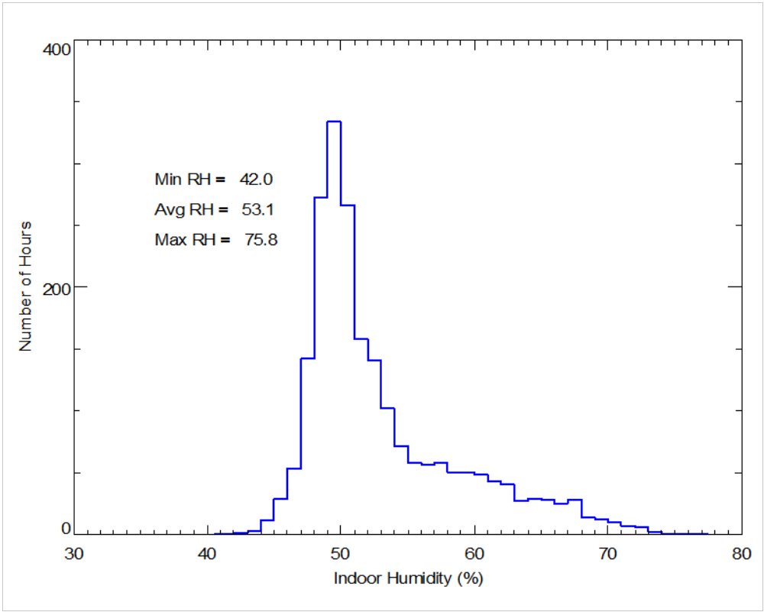
Figure 11. Histogram of Relative Humidity for HERS 100, Miami, System 1, Exhaust Fan

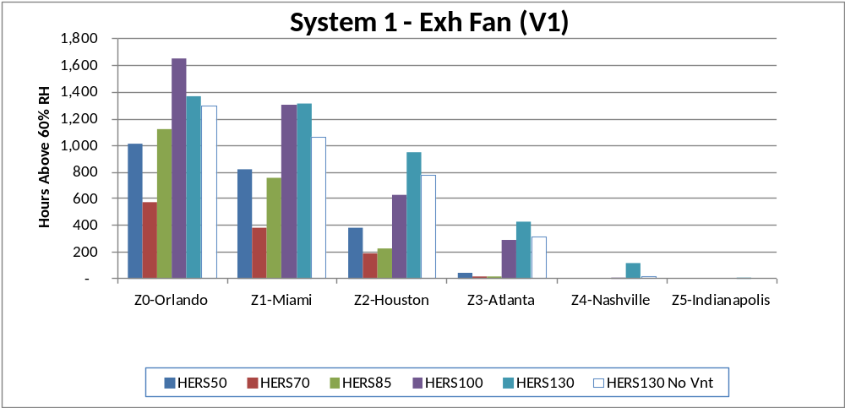
Above 60% RH
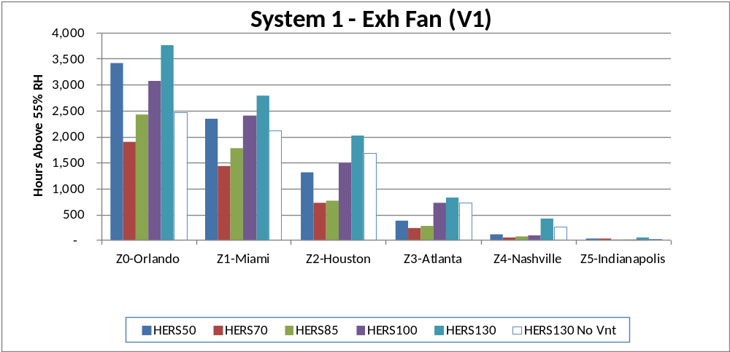
Above 55% RH
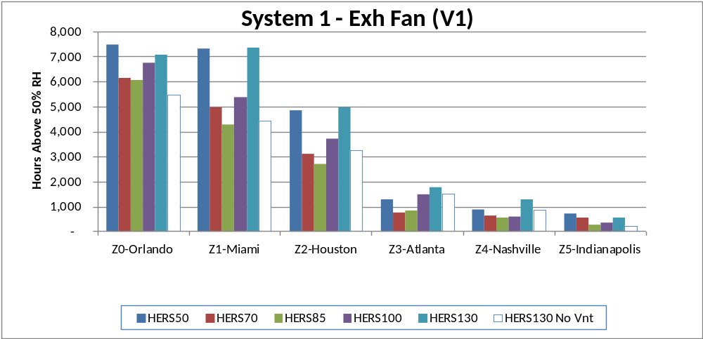
Above 50% RH
Figure 12. Comparing High Humidity Levels for Different Climates and HERS Levels
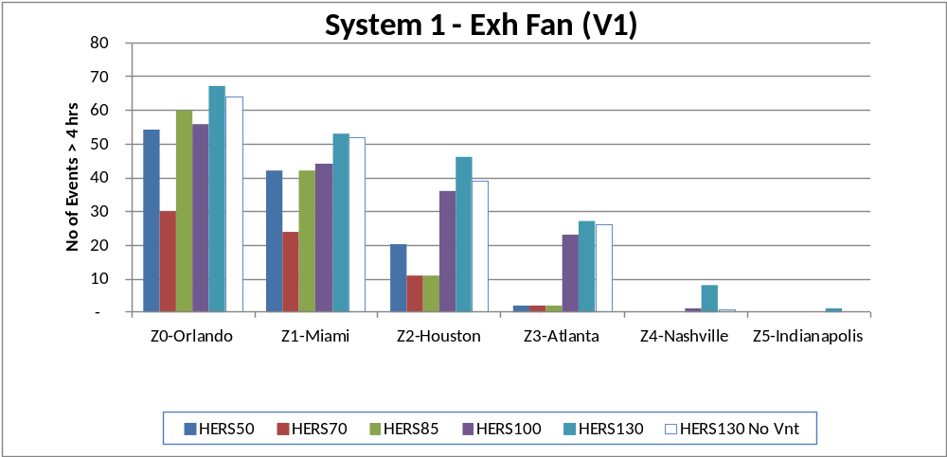
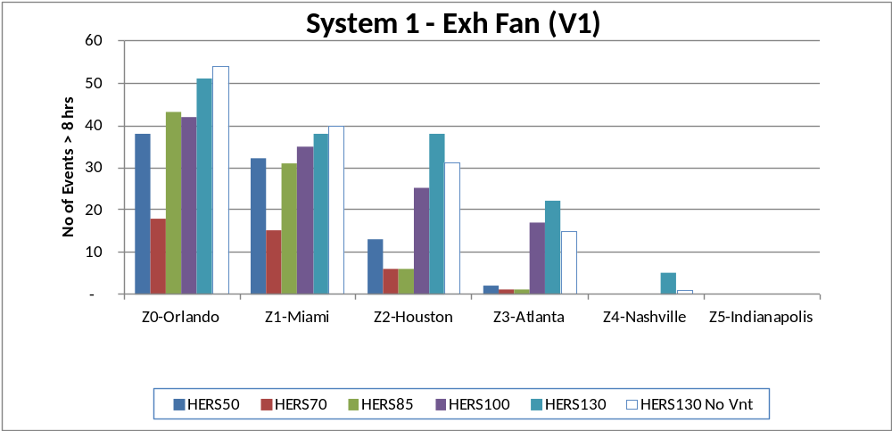
Figure 13. Comparing Number of High Humidity Events (exceeding 60% RH) for Different Climates and HERS Levels

Location of Ducts in the Conditioned Space
One of the main differences between the HERS 70 and HERS 50 houses in the elimination of duct in the attic. Locating the supply ducts in the conditioned space clearly reduces energy use. To further evaluate the impact of duct location on costs and humidity we repeated the HERS 70 run without ducts in the attic and the HERS 50 run was repeated with ducts in the attic. Removing ducts from the attic decreases total costs by 18 to 28% depending on climate and HERS level, as shown by Table 13. Figure 14 also shows that moving the ducts inside the conditioned space clearly results in more hours with high humidity in all cases. The reduction in sensible cooling loads appears to be greater than the latent load reduction, so there is a net increase in humidity levels.

Table 13. Impact of Moving Ducts from Attic to the Conditioned Space
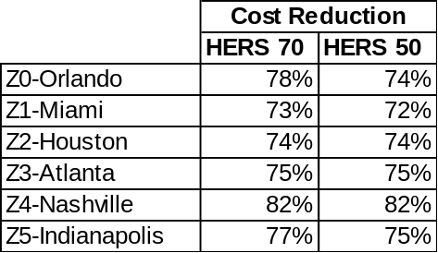

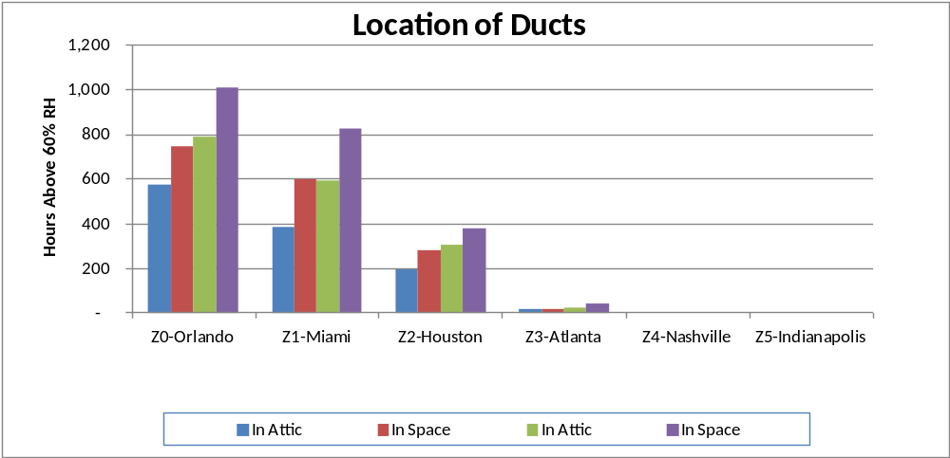
HERS 50
HERS 70
Figure 14. Impact of Duct Location on Space Humidity Levels for HERS 50 and 70 Houses

Impact of Ventilation Options
Several ventilation options were considered in this study. In all cases the interactions between the ventilation option, infiltration and duct leakage were also considered.

- No Ventilation (V0). Fresh to the house is only provided by infiltration. Used for HERS 130 and 100 house only.
- Exhaust Fan (V1). 58 cfm is continuously exhausted from the house. Fan power is 0.4 W/cfm.
- CFI (V2). 174 cfm of fresh air is introduced into the return side of the AHU fan. The AHU fan operates at least 33% of time to provide 58 cfm on average. A ventilation damper shuts if the fan runtime exceeds 33% of the time in the hour. For two-speed AC units the ventilation rate is changed to be 116 cfm for 50% of each hour since the minimum airflow is 50% of full speed flow.
- HRV (V3). The outlet from the HRV is introduced into the return side of the AHU. The HRV supplies 116 cfm for 50% of each hour. The AHU fan is interlocked with HRV fan. HRVs are used in the colder climates (Atlanta, Nashville, Indianapolis)
- ERV (V4). Same operation and control as HRV. ERVs are used in the warmer climates (Orlando, Miami, Houston, Atlanta).
All the ventilation options provide 58 cfm of fresh air in addition to the interactions with natural infiltration and duct leakage. The duct leakage occurs only when the AHU is on and always results in net exhaust (since supply leaks are always greater than return leaks). Figure 15 shows the total combined air change rate for each ventilation system for Miami, HERS 100, System 1. Figure 16 shows a time series plot of the total combined airflow rate (as cfm) for typical winter and summer weeks. The combined ventilation for the balanced ERV system is the highest since mechanical ventilation and infiltration are directly added. The CFI provides more unbalanced ventilation part of the time, which overwhelms infiltration, especially when forces driving infiltration (i.e., wind speed and temperature difference) are low. When infiltration rates are higher (later on the winter week, earlier in the summer week) the combined airflows for CFI and exhaust cases tend to be similar.
Table 14, Table 15 and Table 16 summarize the results for the various ventilation systems in all the climates for three different air conditioners (with different AHU fan options):

- HERS 100, System 1. A 13 SEER AC with a conventional AHU fan (0.5 W/cfm).
- HERS 85, System 1. A 14.5 SEER AC with ECM fan motor (0.35 W/cfm)
- HERS 100, System 3. A two-speed AC with ECM fan motor (0.35 W/cfm, 50% speed for vent)
The different air flows and fan powers associated with these different systems slighting changes the operating cost ranking of the different ventilation options.
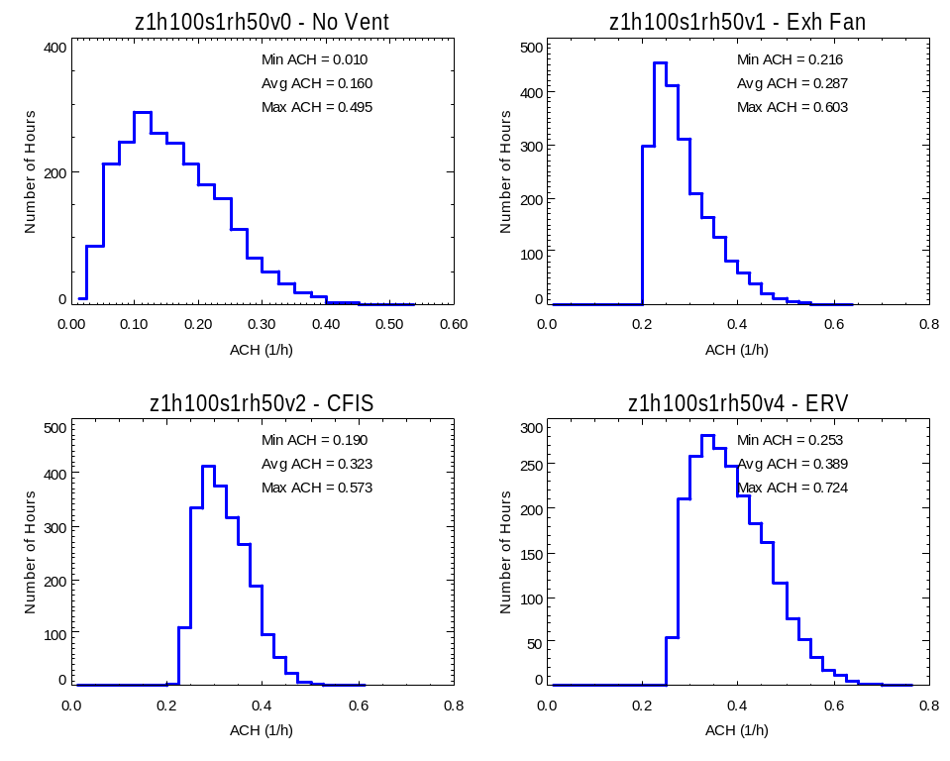
Figure 15. Comparing Total Ventilation Rates (mechanical & natural ACH) for Different Ventilation Systems
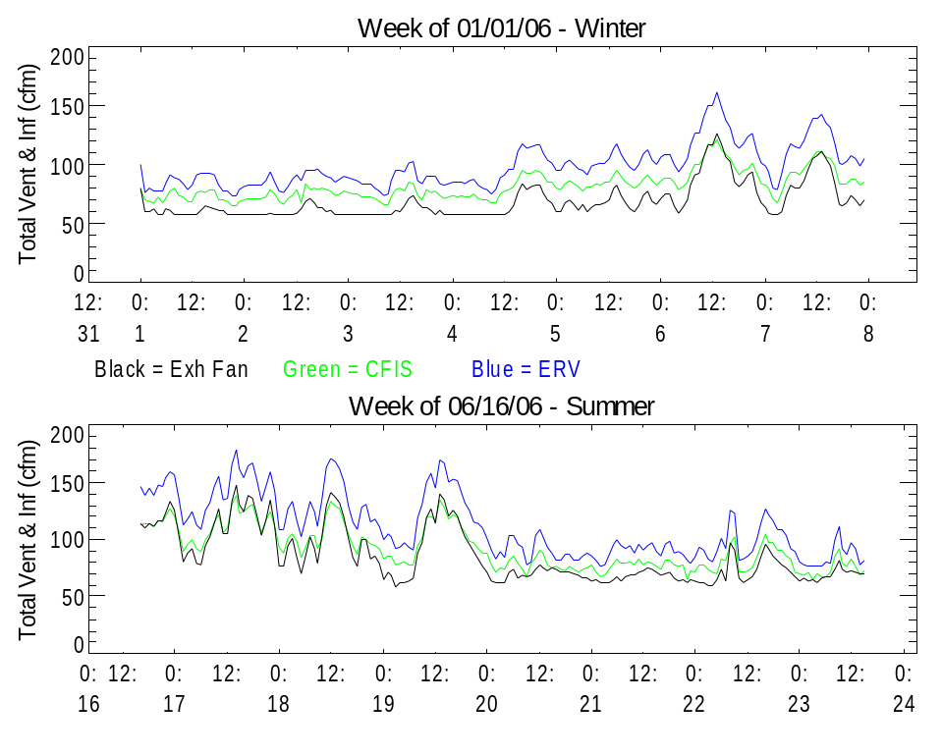
Figure 16. Comparing Total Ventilation Rates (mechanical & natural cfm) for Different Ventilation System

Table 14. Performance Results for Different Ventilation System and Climates (for HERS 100, System 1: 13 SEER AC)
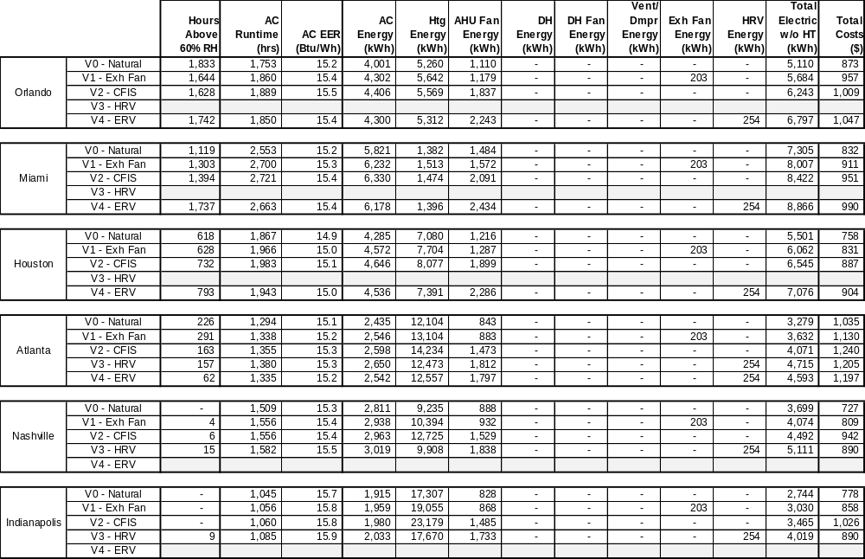

Table 15. Performance Results for Different Ventilation System and Climates (for HERS 85, System 1: 14.5 SEER AC, ECM Fan)
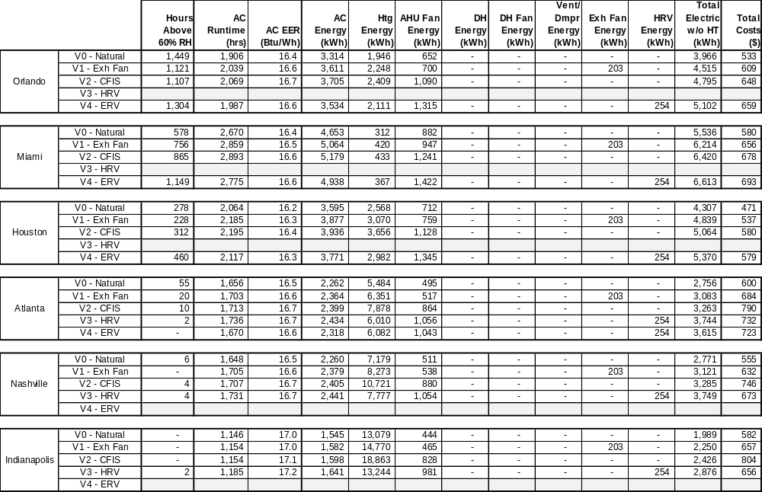

Table 16. Performance Results for Different Ventilation System and Climates (for HERS 100, System 3: Two-Speed AC)
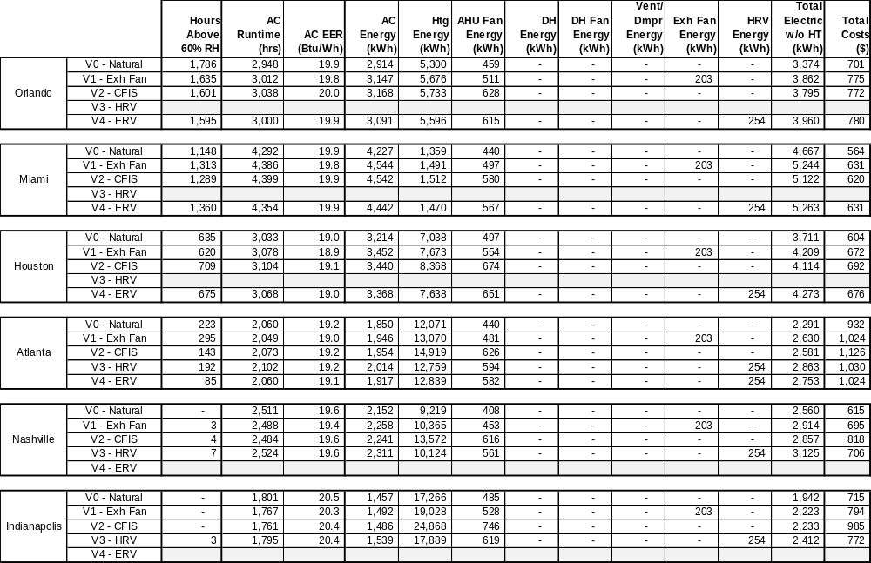

The breakdown of ventilation operating costs for the three different AC systems are shown in Figure 17 for Miami. The electric use of the AC unit, AHU Fan, exhaust fan, and HRV are shown separately. The CFI and ERV options operate the AHU fan to provide mixing in the space so AHU fan power use is greater. The two-speed and 14.5 SEER AC units have ECM fan motors so the energy penalty for mixing is smaller.

Figure 18 compares the total costs, including natural gas costs for space heating, for the different ventilation options. A different plot is given for each AC system. The lowest cost option is the typically the exhaust fan since this does not require additional AHU fan operation. The HRV/ERV does not provide net savings in the humid climates, however, it does provide heating savings in the colder climates. In Atlanta, where both the HRV and ERV where simulated, costs are slightly lower for the ERV.

Figure 19 compares the impact of each ventilation option on the high humidity levels. The number of hours exceeding 60% RH are lowest for the no ventilation case, though this does not satisfy ASHRAE 62.2 ventilation requirements. The ERV results in higher humidity levels, as expected based on previous studies (Henderson 2007). The ERV is ineffective since most of the high humidity hours occur at part load conditions, when there is no difference between indoor and outdoor humidity levels to drive moisture exchange in the ERV. The ERV does slightly reduce humidity levels compared to the HRV in Atlanta. The CFI option results in a slight humidity penalty compared to an exhaust fan primarily due to the part time operation of the AHU fan which degrades the moisture removal capacity of the evaporator coil due to off-cycle air flow.

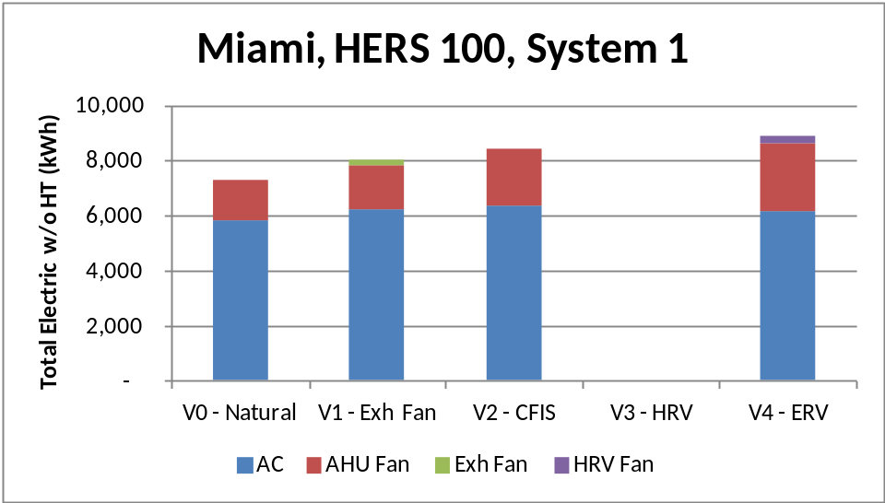
13 SEER AC
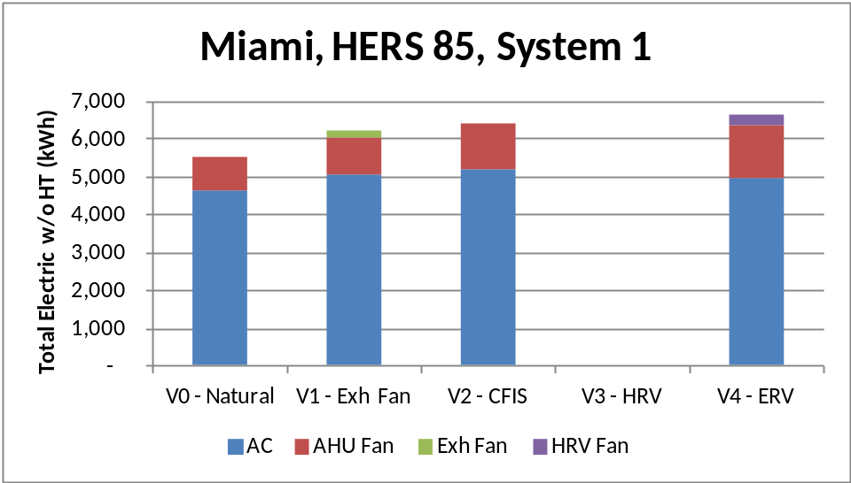
14.5 SEER, ECM Fan
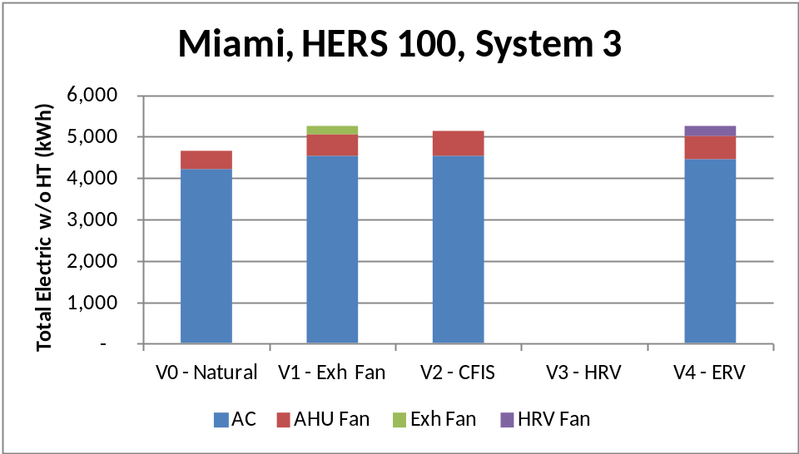
Two-Speed AC
Figure 17. Comparing Total Electric Use for Ventilation Options with Different Systems
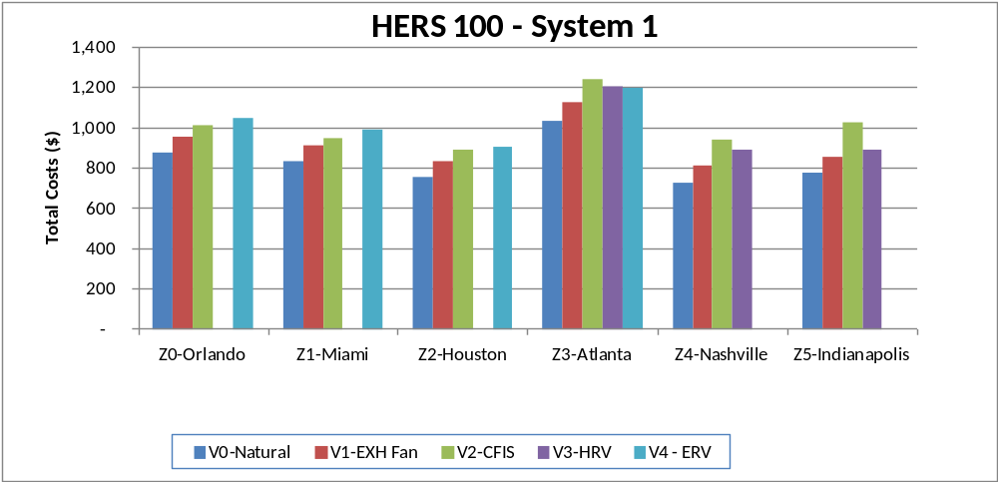
13 SEER AC
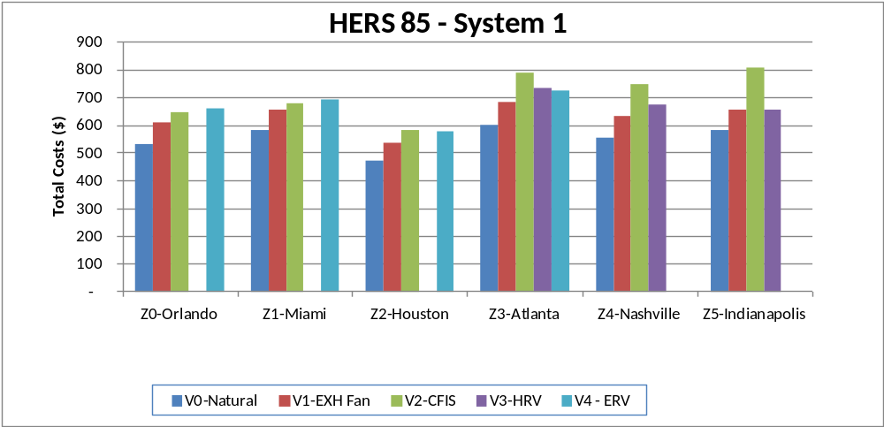
14.5 SEER, ECM Fan
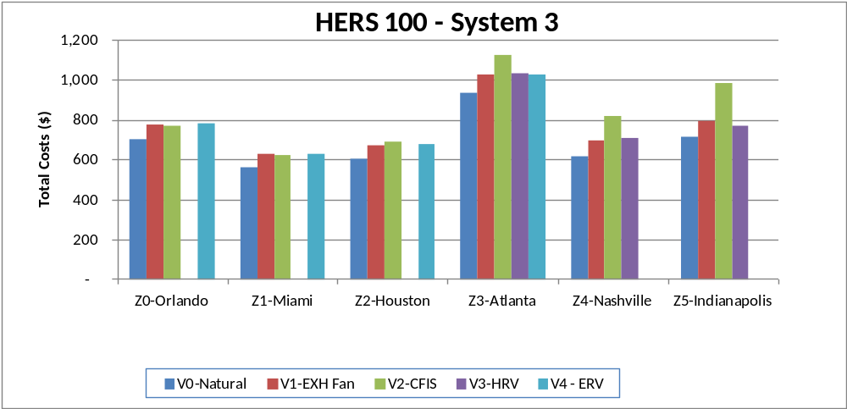
Two-Speed AC
Figure 18. Comparing Total Costs for Different Ventilation Options in each City
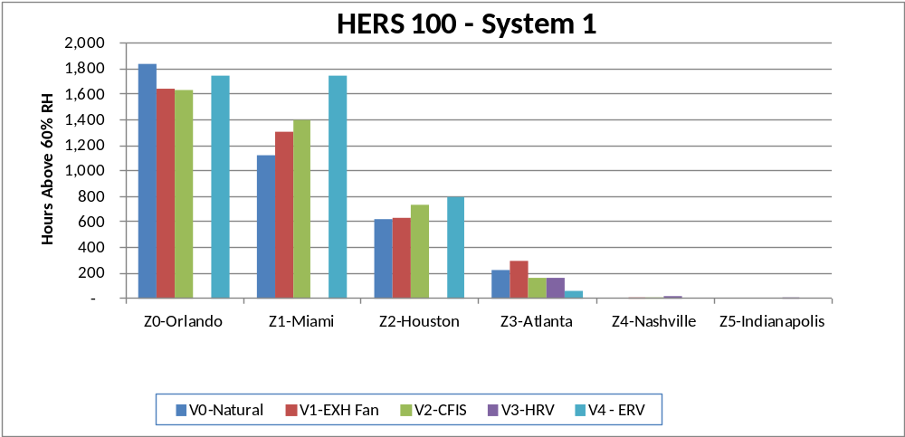
13 SEER AC
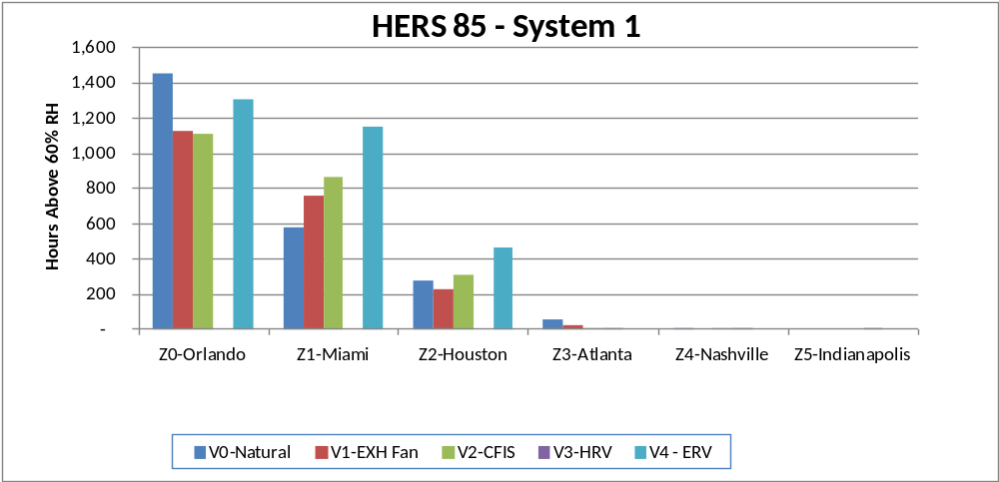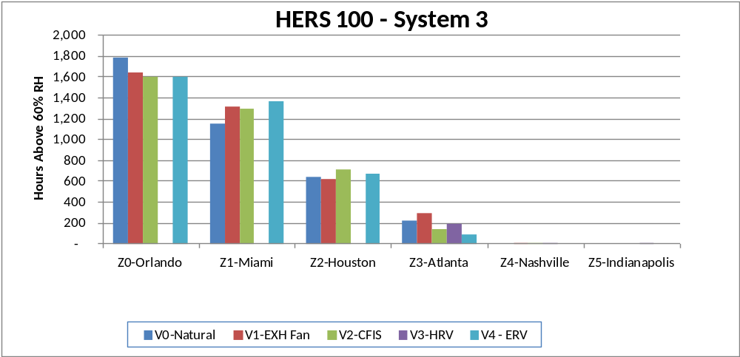
Two-Speed AC
14.5 SEER, ECM Fan
Figure 19. Comparing High Humidity Levels for Different Ventilation Options in each City

Single Speed, Two Speed, and Variable Speed Air Conditioners
Three different AC unit types were considered:
- System 1. Single Speed AC Unit (SEER 13, 0.5 W/cfm fan)
- System 3. Two-Speed AC Unit (SEER 17.7, ECM fan, 50% capacity at low speed)
- System 4. Variable Speed AC Unit (0.1 W/cfm, 30% capacity at lowest speed, ductless)
The data for these systems is summarized in Table 17. The two-speed and variable-speed AC units have commensurately higher EERs as expected. The runtime of the AC units also increases as expected because the units spend significant amounts of time at the lowest speed (the variable-speed AC with 30% minimum capacity has even greater runtime). The degree of humidity control is similar for single-speed and two-speed AC units. This result is not surprising given that the airflow per actual ton for the two-speed is similar in both low and high speed. Therefore the latent removal fraction is similar at all conditions.

The ductless variable-speed system results in higher humidity levels in the HERS 100 house compared to the single and two-speed systems that have the ducts located in the attic. In the HERS 50 house the all the AC units have similar humidity control performance since the all the systems do not have ducts in the attic. These results confirm the finding above that locating the ducts in the conditioned space (and eliminating duct leakage) tends to increase humidity levels.

Table 17. Performance Results for Different AC Units and Climates (for HERS 100 and HERS 50)
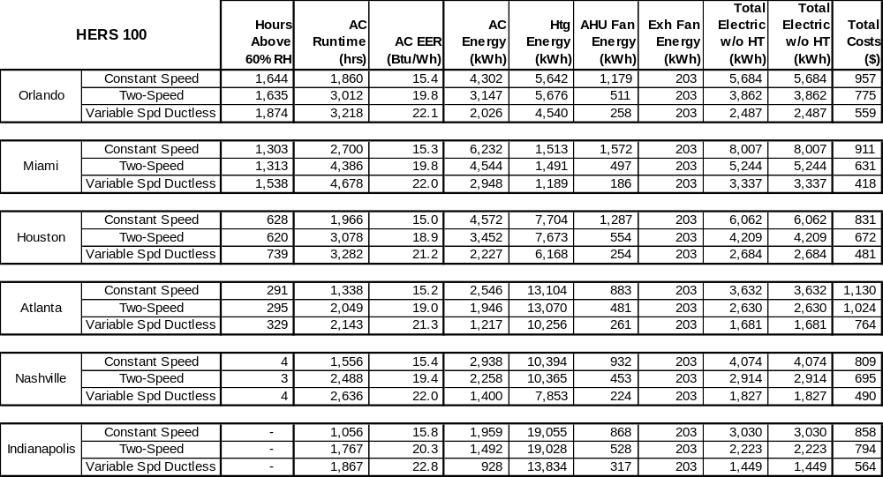

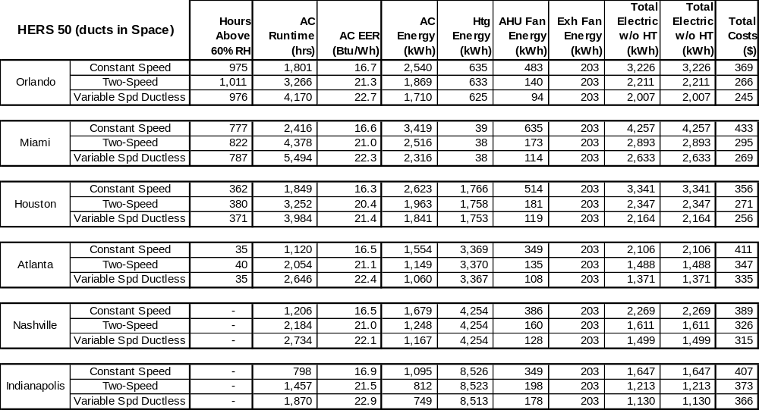

Enhanced Air Conditioner Options
Several control strategies are available to enhance the moisture removal performance of conventional air conditioners. For instance, lowering the air flow tends to reduce the evaporator coil temperature and decrease the sensible heat ratio of the AC unit. Another potential strategy is to continue cooling the space when humidity levels are high. This strategy can result in overcooling of the space (and in extreme cases even higher relative humidity). However it can also make sense if the runtime of the air conditioner is limited. These strategies are often implemented only humidity levels are high and are disabled when space humidity is lower.

The combined strategies listed below:
- Lower the airflow by 53% from 375 cfm/ton to 200 cfm/ton when the space humidity is above the RH setpoint.
- Reset the space cooling set point down by as much as 2°F as the space increases by 10% RH about the set point . Limit AC operation to no more than 50% of each hour while overcooling is occurring.
These two strategies together are called an “enhanced” AC unit (System 2). The performance results for the conventional and enhanced AC unit are compared in Table 18 are compared for single-speed and two-speed units. Activation set points of 50% RH and 60% RH were used. Enhanced AC operation has a significant impact on humidity control as long as the activation set point is 50% RH. The number of hours above 60% RH are reduced by a factor of 2 to 3 depending on the climate in the conventional and two-speed cases. If the activation set point is set to 60% RH, there is almost no impact on the number hours above 60% RH. Clearly these more “passive” humidity control approaches must be activated sooner to be effective.

Table 18. Performance Results with Enhanced AC Unit
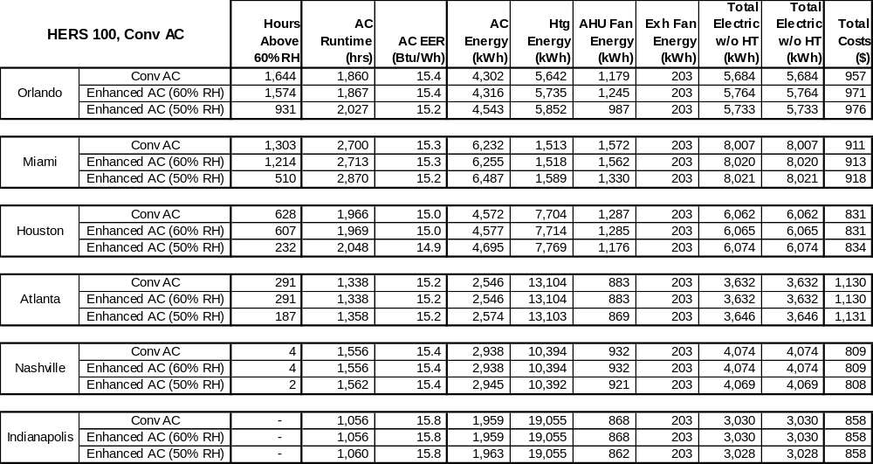
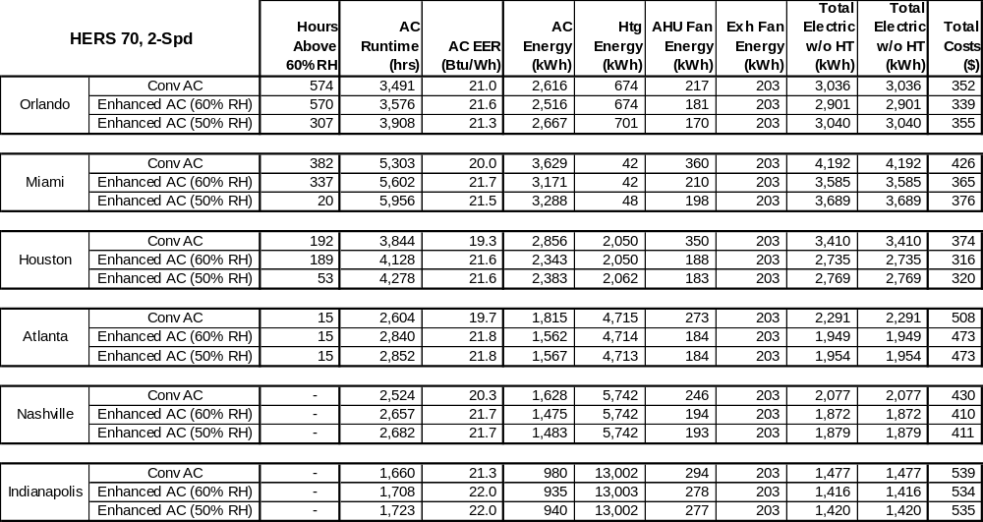

Figure 20 shows the impact that enhanced control on space conditions. The 2°F of overcooling tends to “sweep” down the high humidity days when the space temperature is just below the cooling set point. The only remaining high humidity days correspond to times when the space in in the low 70s.
Conventional AC  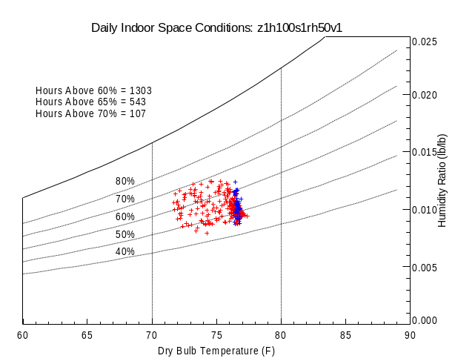 | Enhanced AC – 50% RH Set Pt  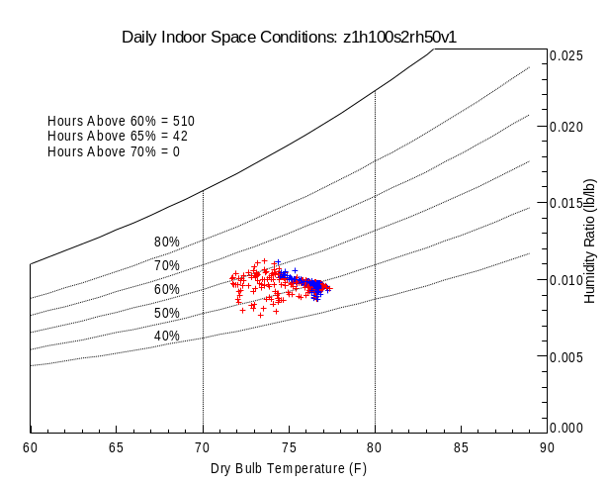  Impact of Enhanced Control
Figure 20. Psychrometric Plots Showing Impact of Enhanced Control in Miami, HERS 100 House

System 10 and System 11 implement each portion of the enhancements separately for the HERS 100, Conventional AC and the HERS 70, Two-Speed Unit in Houston. Overcooling provides slightly more humidity control benefit than lower airflow. Though the two strategies combined does provide greater impact.

Table 19. Performance Results with Various AC Unit Enhancements
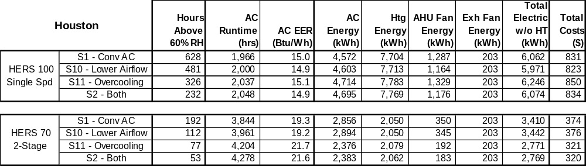

Dehumidifiers

The 50 pint per day stand-alone dehumidifier was simulated with a set point of 50% and 60% RH. The unit was more than adequate to maintain the set point of 60% RH (even though nearly 600 hours slightly exceeded that mark by 1-2 %RH). However, the unit was not fully able to maintain the space at the 50% RH set point (the result was closer to 55% RH. In general the DH unit tended to increase cooling energy requirements slightly while also decreasing heating requirements. Lowering the set point by by only 5-10% RH increased dehumidifier energy use by a factor 5 or more. Total operating costs go up by about $150 per year in the humid climates.

Set Point = 60% RH  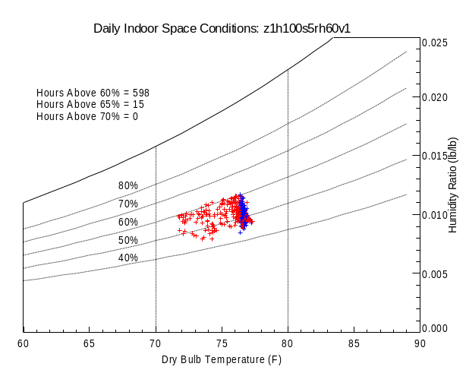 | Set Point = 50% RH  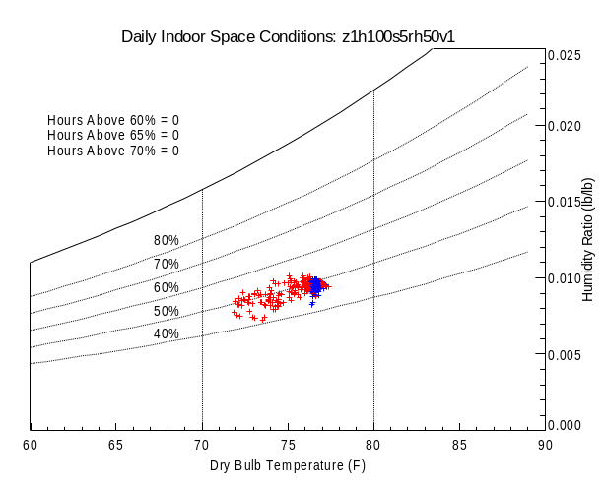
Figure 21. Psychrometric Charts Comparing the Degree of Humidity Control at Two RH Set Points for Standard DH unit, HERS 100, Miami

Table 20. Performance Results with Standalone DH (System 5) with Different Set Points
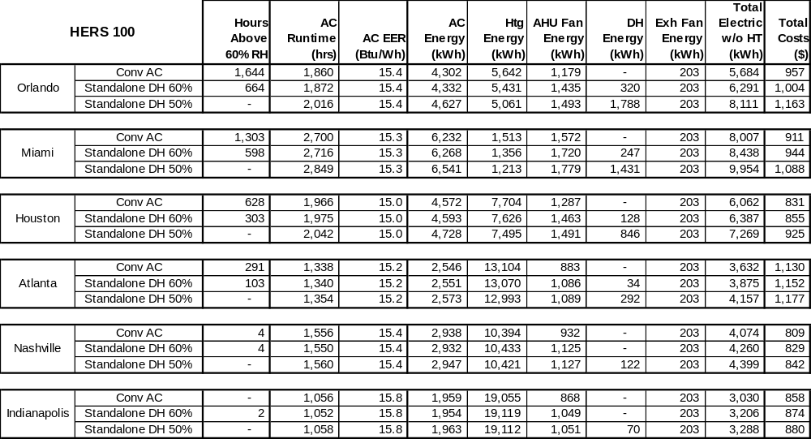

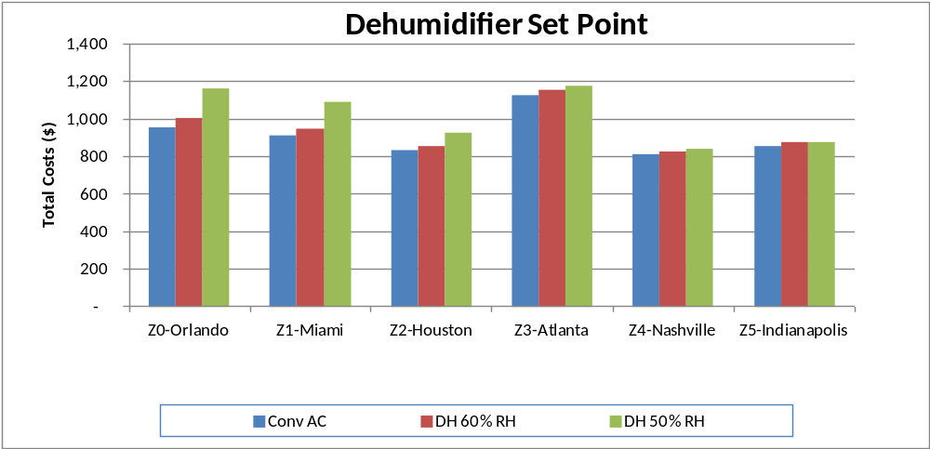
Figure 22. Total Operating Costs for Standalone DH at Various RH Set Points, HERS 100 House
Various types of high performance dehumidifiers were tested, including:

- System 6. A high efficiency, 65 pint per day, ducted DH unit with EF of 2.0 L/kWh and fan power of about 0.7 W/cfm.
- System 7. A high efficiency, 82 pint per day unit (2.0 L/kWh) set up to also provide ventilation to the home. The unit uses its fan to provide 174 cfm to the space year-round, with 33% of that airflow from outdoors.

Table 21. Performance Results with Various DH Units (Systems, 5, 6, 7 and 13) with 60% RH Set Point (for DH)
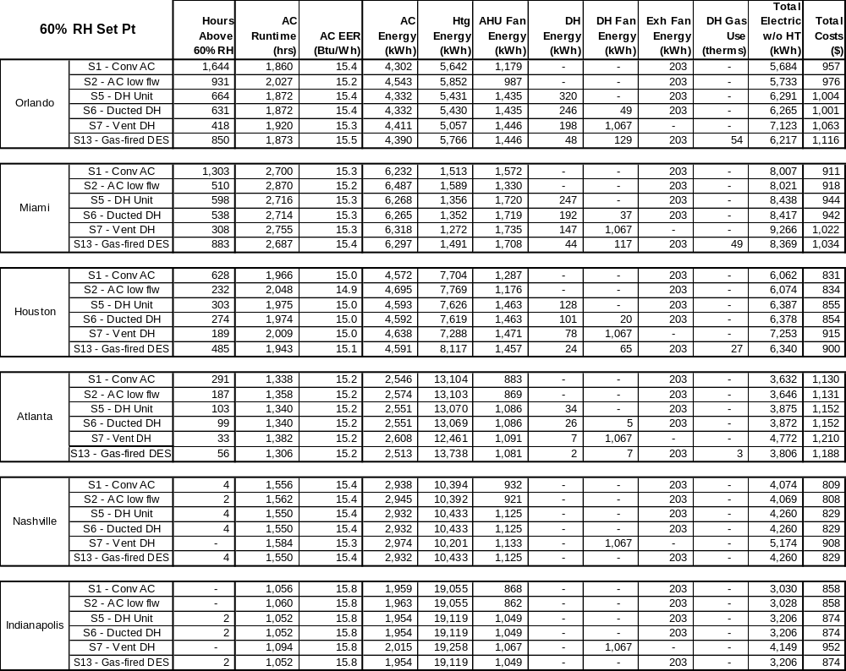

Table 22. Performance Results with Various DH Units (Systems, 5, 6, 7 and 13) with 50% RH Set Point (for DH)
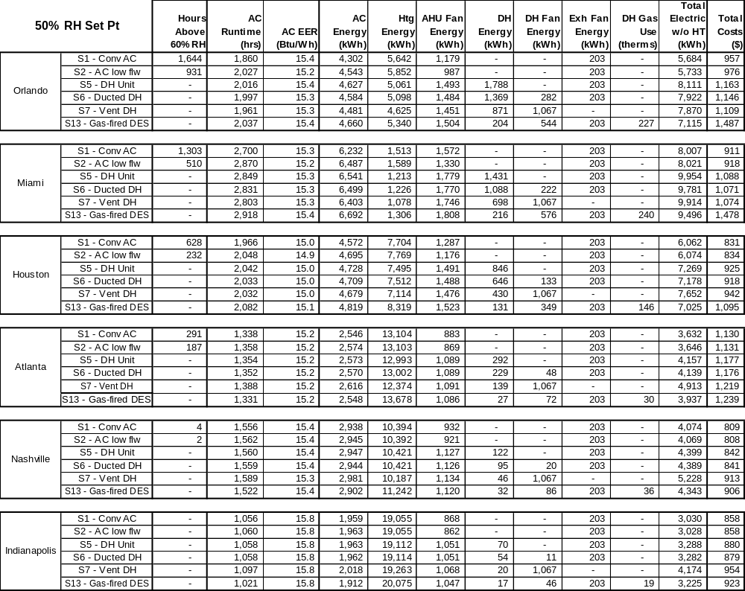

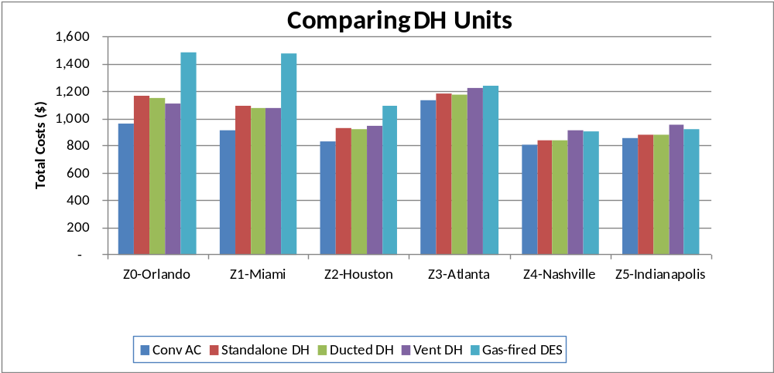
Figure 23. Total Operating Costs All DH Options, 50% RH Set Point, HERS 100 House

Conclusions and Recommendations

tbd

References

ASHRAE. 2009. 2009 ASHRAE Handbook – Fundamentals, Chapter 16 (Ventilation and Infiltration), pp. 16.23-16.24. Atlanta, GA: American Society of Heating, Refrigerating and Air-Conditioning Engineers, Inc.
Christensen, D. and J. Winkler. 2009. “Laboratory Test Report for ThermaStor Ultra-Aire XT150H Dehumidifier.” NREL Technical Report, NREL/TP-550-47215, Golden, CO: National Renewable Energy Laboratory.
Hendron, R. 2008. “Building America Research Benchmark Definition.” Technical Report, NREL/TP-550-44816, Updated December 19, 2008, National Renewable Energy Laboratory, Golden, CO.
Larson, B. 2010. Informal data exchange from test run on a mini-split system at Purdue University, Herrick Labs. Ecotope Inc., Seattle, WA.
Thermastor 2010. Email communication with factory engineers. Therma-Stor LLC, Madison, WI.
Ueno, K. 2010. ECM Efficiency: Better (and Worse) Than You Think, Home Energy Magazine, May/June.
Walker, I. and D. Wilson. 1998. “Field Validation of Algebraic Equations for Stack and Wind Driven Air Infiltration Calculations.” International Journal of HVAC&R Research (now ASHRAE HVAC&R Research Journal), Vol. 4, No. 2, April.

Need to update

A publicly-available version of TRN-ResDH is available at http://www.cdhenergy.com/trn-resdh2/. An updated version and documentation will be available to the PMS at the conclusion of this project.
Reference Manual for IHAT simulation tool
AHAM rating point is 80°F and 60%RH. Systems are rated at zero static.
Energy Factor (EF) of 3.3 L/kWh is based on the AHAM conditions of 80 F and 60% RH (though Munters does not specify what outdoor humidity and temperature are used to develop the rating, we have inferred it using the software tool). The Munters HD unit also goes by the name of the Model DC120 or the DryCool Mini. Novelaire makes a similar unit (Comfort 300) which has a rated EF of EF of 2.6 L/kWh.

